# Species Diversity, Richness, and Distribution Patterns of Lepidoptera in Semi-Urban Farmland and Various Habitats Surrounding Lumbini Parsa-Chauraha, Rupandehi District

                                                      

**Submitted by Celeus Baral**

**UoN ID: 22429947**

**Thesis for a Degree in BSC. (Hons) Environmental Science**

**Faculty of Arts, Science, and Technology**

**Naaya Aayam Multidisciplinary Institute (NAMI)**

**The University of Northampton (UoN)**

**September 2024**

# Declaration

I, Celeus Baral, a student pursuing a bachelor's degree in environmental science at NAMI College, University of Northampton, hereby declare that the research work contained in this thesis, "Species Diversity, Richness, and Distribution Patterns of Lepidoptera in Semi-Urban Farmland and Various Habitats Surrounding Lumbini Parsa-Chauraha, Rupandehi District," is original and independent work that I completed on my own, with assistance and oversight from my supervisor Rajana Maharjan ma’am. No other university or institution has received this work, in whole or in part, to award a degree or certificate. This thesis's contents are the product of my study, and I have properly acknowledged any help I got along the way. I have carefully followed the University of Northampton's ethical standards and procedures when doing research. Every informational, factual, and literary source that was used to prepare this thesis has been properly cited and referenced. I accept full responsibility for any mistakes or missing information in my thesis. I verify that this work is free of plagiarism and other academic misconduct, and I am fully aware of the repercussions of doing so.

# Acknowledgment

I would first like to express my sincere appreciation to my supervisor, Miss Rajana Maharjan, ma’am. Her steadfast assistance, perceptive criticism, and committed direction have been invaluable in writing this thesis. Her support and knowledge have always been an inspiration, and without her great help, our effort would not have been possible. I have the utmost gratitude for my parents' persistent support and dedication to my education. Their confidence in my skills has motivated me the entire time I've been an academic. My father. Hem Sagar Baral, deserves special recognition for his invaluable instruction and professional support throughout the fieldwork, which were essential to the success of this study. The effective completion of this thesis may be attributed to his exceptional knowledge, contributions, and unwavering devotion. Finally, I would like to express my gratitude to our program leader, Mrs. Sumitra Prajapati ma'am, and NAMI College for giving me this amazing opportunity to work on my thesis. Their assistance has been invaluable in making this project an accomplishment.

# Abstract

This study comprehensively assessed Lepidoptera diversity in semi-urban agricultural settings, documenting 30 moth species from six families and 39 butterfly species from five families within 14 days in Lumbini. Dominance was observed in the Erebidae family for moths and Nymphalidae for butterflies, with the former exhibiting high adaptability to disturbed habitats. Key factors influencing species abundance included weather patterns, lunar phases, and habitat characteristics, highlighting the resilience of species like Erebidae and Noctuidae in changing environments. The findings indicate that diverse plant communities significantly shape Lepidoptera populations, with agricultural and shrubland habitats supporting greater species richness and evenness compared to grasslands. The study underscores the intricate relationships between species and their habitats, emphasizing the ecological roles of both moths and butterflies. Continuous monitoring of these populations is essential for understanding their dynamics and ensuring biodiversity conservation in light of environmental changes.

# Table of contents

**Declaration 2**

**Acknowledgment 2**

**Abstract 3**

**List of Tables 7**

**List of Figures 8**

**List of Abbreviations 9**

**Chapter 1: Introduction**

1.1. Background 9

1.2. Distribution in Nepal 10

1.3. The Vital Role of Lepidoptera in Plant-Pollinator Interactions 10

1.4. Research gap and the statement of the problem 11

1.5. Rationale 11

1.6. Objectives 12

1.7. Limitations of the study 12

**Chapter 2: Literature Review**

2.1. History of Lepidoptera 13

2.2. Lepidoptera Diversity across Nepal's Varied Elevations 14

2.3 Plant-Pollinator Connections: The Role of Flowering Plants in Sustaining Lepidoptera Diversity in Nepal 15

2.4. Global and national: vulnerability, threats, and decline 15

**Chapter 3: Materials and Method**

3.1. Study area 17

3.2. Climate 18

3.3. Vegetation, Flora, Fauna and Habitats 19

3.4. Data collection 19

3.5. Data analysis 21

**Chapter 4: Results**

4.1. Distribution of the moth family 24

4.2. Whittaker plot of moth species 25

4.3. Table of diversity indices, richness, and evenness of all of the 6 moth families and their overall total 26

4.4. Distribution of the butterfly family 27

4.5. Whittaker plot of butterfly species 28

4.6. Table of diversity indices, richness, and evenness of all of the 5 butterfly families and their overall total 29

4.7. The family-wise categorization of butterfly richness in 5 different habitats 30

4.8. The Shannon Diversity Index and Pielou’s Evenness Index of the Overall Butterfly Richness in 5 different Habitats 31

4.9: The total vegetation recorded with their origin and the butterfly species that visited the most 32

**Chapter 5: Discussion**

5.1. Family Dominance and Diversity of Moth Species 35

5.2. Species Adaptation in Semi-Urban Agricultural Land: Moths in a Lemon Farm 35

5.3. Influence of Weather patterns, Lunar phase, Light Traps, and Nocturnal Habits 36

5.4. Status and Abundance Patterns of Moth Species 37

5.5. Factors Influencing the Moth Species Dominance and Distribution in Rank Abundance Plot 38

5.6. Species Richness and Diversity of Butterfly Families 38

5.7. Rank-Abundance Analysis of Butterfly Species: Patterns of Dominance 39

5.8. Habitat Influence on Butterfly Species Richness and Diversity 39

5.9. Influence of vegetation across habitats affecting the overall diversity of butterflies 40

**Chapter 6: Conclusion 42**

**Chapter 7: Recommendations 42**

**Reference list 43**

**List of Appendices**

**Appendix 1: Logbook 54**

**Appendix 2: A Checklist of Moth Species and Their Abundance, Categorized By Their Family, And Status Recorded 55**

**Appendix 3: The List of Butterfly Species Recorded Categorized By the Total Number of Families, And Individuals Found In Various Habitats 60**

**Appendix 4: The Calculation of the Species Diversity, Evenness, Richness, and Abundance of Moth Species 67**

**Appendix 5: The Calculation of Butterfly Species Diversity, Richness, Evenness, and Abundance 70**

**Appendix 6: Calculation of the Rank-Abundance (Whittaker) Plot of the Recorded Moth Species-Script for the Plot 74**

**Appendix 7: Calculation of the Rank-Abundance (Whittaker) Plot of the Recorded Butterfly Species-Script for the Plot 76**

**List of Annex**

**Annex 1: Photos of Moth Species Recorded 80**

**Annex 2: Photographs of Butterfly Species Frequently Shot While Resting on or Interacting with Their Post Plants 89**

**Annex 3: Photographs of Habitats That Were Explored for the Butterfly Diversity 96**

# List of Tables

**Table 1:** Table of diversity indices, richness, and evenness of all of the 6 moth families and their overall total 26

**Table 2:** Table of diversity indices, richness, and evenness of all of the 5 butterfly families and their overall total 29

**Table 3:** The Shannon Diversity Index and Pielou’s Evenness Index of the Overall Butterfly Richness in 5 different Habitats 31

**Table 4:** The total vegetation recorded with their origin and the butterfly species that visited the most 32

# List of Figures

**Figure 1:** Study Area Map 17

**Figure 2:** A polygon map of the habitat distribution across the study area 18

**Figure 3:** The moth trap and its setting and the 50-watt light lit during nighttime 20

**Figure 4:** The study was conducted based on observation and observed *Ideopsis vulgaris*. 21

**Figure 5:** The distribution of moths by the families in percentage 24

**Figure 6**: Rank-abundance plot of moth species observed 25

**Figure 7**: The distribution of the butterflies by the families in percentage 27

**Figure 8**: Rank-abundance plot of butterfly species observed 28

**Figure 9**: The family-wise categorization of butterfly richness in 5 different habitats 30

# List of Abbreviations

**AGR** Agricultural Land

**BCN** Bird Conservation Nepal

**C** Common

**D** Simpson's Diversity Index

**Dmg** Margalef's Richness Index

**DNPWC** Department of National Parks and Wildlife Conservation

**DoFSC** Department of Forest and Soil Conservation

**FC** Fairly Common

**FSR** Forested Area

**H'** Shannon-Weiner Index

**J'** Pielou's Evenness Index

**LDT** Lumbini Development Trust

**LED** Light-Emitting Diode

**LMP** Lumbini Master Plan

**R** Rare

**Sps** Species

**SHR** Shrubland

**UNESCO** United Nations Educational, Scientific and Cultural Organization

**VR** Very Rare

**WTL** Wetland

# Chapter 1: Introduction

## 1.1. Background

Lepidoptera, comprising moths and butterflies, is one of the largest and most recognized insect orders, with around 160,000 species globally (Perveen & Khan, 2017). Characterized by their scales and proboscis, they undergo complete metamorphosis in four stages: egg, larva (caterpillar), pupa, and adult (Gibb, 2015). Moths, accounting for the majority of species, belong to 30 superfamilies, with families like Noctuidae (about 35,000 species) and Geometridae (around 21,000 species) being the largest (New, 2004). Butterflies, on the other hand, are divided into 46 superfamilies, with Nymphalidae and Lycaenidae (both around 6000 species) being prominent (Iqbal *et al*., 2016). Moths are mainly nocturnal, while butterflies are diurnal and more vibrant. Both groups are vital pollinators, particularly moths for night-blooming flowers, contributing to plant reproduction and ecosystem stability (Pradhan *et al*., 2024). Additionally, moths play a role as herbivores, influencing plant population control and nutrient cycling. Butterflies, known for their beauty, assist in long-distance pollen distribution, boosting plant genetic diversity (Goldstein, 2017). Due to their sensitivity to environmental changes, Lepidoptera are often used as ecological indicators (Dar & Jamal, 2021). Conservation efforts often prioritize Lepidoptera due to their public appeal, but focusing on diversity rather than specific taxa can benefit broader ecological communities (New, 1997). Additionally, these insects are critical for ecosystem health, evolutionary biology, and pest management, highlighting their ecological importance.

## 1.2. Distribution in Nepal

Nepal's diverse habitats, spanning tropical Terai plains to the alpine regions of the Himalayas, support a wide range of Lepidoptera (Choudhary and Chishty, 2020). In the tropical and subtropical zones, especially in the Terai, dense forests provide ample feeding and breeding opportunities for many species. The mid-hills’ shrublands and grasslands, characterized by various grasses and low-lying plants, host an abundance of butterflies and moths. Wetlands like Jagdishpur Taal attract species whose larvae require moisture. In agricultural areas, Lepidoptera thrive on crops and surrounding vegetation, while temperate woodlands in the mid-hills support species adapted to cooler climates. Alpine meadows in the Himalayas are home to specialized species that survive in high-altitude conditions (Smith, 2010, p.2). Even urban gardens offer crucial habitats, making Nepal an ideal region for studying Lepidoptera diversity across varied ecosystems. Around 663 butterfly species have been identified in Nepal (Sapkota, KC and Pariyar, 2020) and 6,000 macro moth species have been recorded (Smith, 2010, p. 1). The diversity of habitats found in Nepal's climatic and geographical zones reflects the country's ecological complexity and richness in Lepidoptera. Each ecosystem supports distinct types of butterflies and moths, making Nepal a perfect place for researching these critical ecological markers.

## 1.3. The Vital Role of Lepidoptera in Plant-Pollinator Interactions

Butterflies play an important part in pollination by dispersing pollen while feeding on nectar. Tiny scales on their bodies collect pollen from one bloom and transport it to another, facilitating plant reproduction. Many flowers provide nectar rich in amino acids, which helps butterflies survive and reproduce. Butterflies' unusual proboscises allow them to consume nectar from a variety of flowers, fostering genetic diversity in plants by dispersing pollen across great distances (Jennersten, 1984). Approximately 87.5% of blooming plants rely on animal pollinators, with nocturnal moths being especially important yet sometimes underestimated (Katumo *et al.*, 2022). Moths from the families Sphingidae, Noctuidae, and Geometridae are important evening pollinators in tropical rainforests and temperate woods (Katumo *et al.*, 2022). Their involvement in pollination promotes interpopulation gene flow, long-distance pollen dispersal, and efficient pollen transfer. Unlike butterflies, which are active during the day and favor vividly colored flowers, moths' nighttime activities highlight their critical role in pollination (Macgregor *et al*., 2014). Understanding the pollination roles of moths and butterflies is critical to preserving these ecological linkages and devising successful conservation measures.

## 1.4. Research gap and the statement of the problem

Although Nepal has a rich biodiversity and has been recognized for successful conservation and habitat management efforts, such as the recent increase in tiger populations in the lowlands (Fitzmaurice *et al*., 2021), smaller species such as butterflies and moths are frequently overlooked and under-prioritized. Nepal's research has been highly focused on larger animals, leaving a considerable gap in insect studies (Jnawali et al., 2011). While few species-specific studies have been on Lepidoptera ((Owada, 1981; Khanal and Shrestha, 2022) comprehensive diversity studies remain rare, particularly for moths. The diversity and richness of moths in different regions of Nepal are still barely studied, emphasizing the necessity of comprehending the functions of these essential ecological indicators across a range of habitats, elevations, and climates.

Lumbini's rich natural history and diverse ecosystems—comprising farmlands, wetlands, forests, and shrublands—are vital for sustaining various forms of life (Baral 2018). Studying the diversity, richness, abundance, and distribution of lepidopterans, which serve as important ecological indicators, is essential for informing conservation policies and assessing the region's environmental health (Thomas, 2005). Given Nepal's varied terrain, this field has significant potential for further research. Enhancing the understanding of moth and butterfly status, roles, and ecological services in Nepal will contribute valuable insights to biodiversity conservation efforts.

## 1.5. Rationale

The study aims to enhance understanding of Lepidoptera's status and distribution in the Lumbini Sanskritik Municipality while paving the way for future research. Lepidoptera plays a crucial role in local agriculture by pollinating crops and supporting sustainable farming practices (Katumo *et al.*, 2022). Documenting species in semi-urban farmlands will identify key pollinators and their impact on crop production, contributing to the development of integrated pest management techniques that balance pest control with the conservation of beneficial species. This research will raise awareness about Lepidoptera's importance, encouraging community involvement in conservation efforts and promoting sustainable farming practices. By providing valuable data on species diversity and distribution, the study will guide habitat conservation priorities and offer early indicators of environmental changes. Farmers can adopt strategies that support Lepidoptera, such as reducing pesticide use and preserving diverse habitats, fostering ecological balance, and sustainable agriculture. This study will lay the foundation for future research on Lepidoptera in the area.

## 1.6. Objectives

The study aims to accomplish three key objectives:

1. To assess species diversity and richness of Lepidoptera in Lumbini Sanskritik Municipality of Rupandehi District, focusing on the variety of butterfly populations across habitats such as agricultural fields, forests, wetlands, grasslands, and shrublands.
2. To investigate how varied ecosystems influence butterfly species and family distributions, analyzing the impact of habitat types—such as agricultural lands, shrublands, forests, and wetlands—on butterfly distribution and abundance.
3. To examine the relationship between moth diversity, richness, and evenness with environmental factors like weather conditions and moon phases. This will offer insights into the ecological preferences of these insects, enhancing understanding of their role in the ecosystem.

## 1.7. Limitations of the study

This study has several limitations. The 14-day duration and restricted geographic area may have constrained the data collected. Conducted from February 19 to March 4, 2024, it couldn't capture seasonal fluctuations in Lepidoptera populations. A 50-watt light was used for moth trapping instead of the more effective mercury vapor lamp, which may have impacted the recordings of moth species. Technical and financial constraints also hindered a detailed habitat study for moth diversity. Additionally, early spring rain interrupted observations, and challenges in identifying moths arose due to limited local research and guidebooks.

# Chapter 2: Literature Review

## 2.1. History of Lepidoptera

Lepidoptera has a 200 million-year evolutionary history (Chen *et al*., 2023). Studies by Whalley (2024) claim that fossils, which include species that resemble moths from the Jurassic period, show how Lepidoptera gradually evolved in connection with the emergence of flowering plants throughout the Cretaceous period, resulting in an astounding diversity. Nepal's history in the study of Lepidoptera began in the early 19th century (Smith, 2010, p. 1). Despite significant challenges in accessibility, records before the mid-20th century were highly restricted (Smith, 2010, p. 1). Butterfly studies started with the research carried out by General Thomas Hardwick in late 1826 A.D. (Khanal and Smith, 1997). It was Major W.G.H. Gough who originally assembled a list of 150 species from Nepal in 1935 A.D. (Sapkota, KC, and Pariyar, 20s20). Between 1852 and 1867, Major General Ramsey classified 44 species, and Lt. Col. F.M. Bailey recorded 365 species (Sapkota, Kc and Pariyar, 2020). A Japanese expedition in 1970 identified 285 species of Lepidoptera, which were relatively unknown to science at the time. While Colin Smith's work between 1978 and 1994 collected and classified hundreds of species, resulting in several books (Smith, 2011, p.144; Smith, 2010, p. 184) and also listing 660 species and 30 subspecies (Smith, 2010, p. 1). Another study claimed 29 subspecies of the 663 butterfly species identified in Nepal (Sapkota, Kc and Pariyar, 2020). Future research is expected to discover and document more butterfly species and subspecies.

Moth studies in Nepal gained momentum in 1961, marked by annual publications from experts. Haruta (1992, p.170) led the "Moths of Nepal" initiative, which cataloged numerous moth families. Colin Smith later added species from other sources, reflecting ongoing taxonomic changes. After 1950, international teams from Japan, Germany, and Canada significantly enhanced their knowledge of Nepal's moths, estimating around 6,000 macro-moth species (Smith, 2010, p. 184).

## 2.2. Lepidoptera Diversity across Nepal's Varied Elevations

Nepal’s varied terrain, from tropical lowlands to alpine zones, fosters a rich diversity of Lepidoptera influenced by temperature, humidity, and light. Khanal *et al.* (2013) found that elevations above 2500 meters in Langtang National Park support species like *Neptis ananta ochracea* and *Atrophaneura latreillei*. Pandey *et al*. (2017) noted a decline in butterfly richness with altitude in Langtang, a trend echoed by Acharya and Vijayan (2015) in the Eastern Himalayas, where only 3% of species occur above 2000 meters. Conversely, Shrestha *et al.* (2020) observed increasing butterfly diversity in Manang with elevation, likely due to unique climatic conditions. Moths also exhibit adaptations at higher elevations; Dewan and Shrestha (2021) identified 13 species from the Noctuidae and Geometridae families at 3800 meters in Gaurishankar Conservation Area. Sanyal *et al.* (2013) reported similar trends in India’s Gangotri landscape similar to Gaurishankar. Moth diversity peaks between 500 and 1500 meters in wet temperate and montane subtropical forests, declining at higher elevations (2500–3500 meters) with subalpine vegetation.

In Nepal’s hilly regions, Miya *et al*. (2021) identified the Nymphalidae family as the most species-rich in Tanahun, including rare species like *Sinthusa chandrana* and *Gandaca harina*. Forests had the highest diversity due to rich plant life and low disturbance, while agricultural fields supported fewer species, likely due to chemical use and intensive farming. Similarly, Oli and Sharma (2019) found Nymphalidae prevalent in Kirtipur, Kathmandu, with urbanization leading to habitat fragmentation. Haruta (1993) documented around 120 moth species in the Godavari region, while Ahmad Dar *et al.* (2021) noted diverse topography in the Aravalli Hill Range, mirroring conditions to Nepal’s Siwalik Hills. Studies by Paudel, Shah, and Bashyal (2024) revealed a significant research gap in lowland butterflies, with only 4% of species documented in Thakurbaba Municipality, Bardiya. Their findings indicated that cold temperatures and adverse weather negatively affect butterfly activity, with common species including *Pieris canidia, Mycalesis perseus*, and *Melanitis leda*. Choudhary and Chishty (2020) emphasized butterflies' need for minimal environmental disturbance. Research on lowland moths is also limited; Dubey and Dubey (2019) identified 92 species in Uttar Pradesh, while Ahmed *et al*. (2024) found 129 species in Assam’s Mahamaya Reserve Forest. These studies suggest that lowland areas may support greater moth diversity than higher altitudes, where harsher conditions limit species richness (Highland, Miller, and Jones, 2013).

## 2.3. Plant-Pollinator Connections: The Role of Flowering Plants in Sustaining Lepidoptera Diversity in Nepal

Lepidoptera, including butterflies and moths, are closely linked to flowering plants (angiosperms), which are crucial for their reproduction. Butterflies feed primarily on nectar and sometimes pollen, using their tube-like proboscis for both feeding and pollination. While some species have specific flower preferences, many are adaptable, selecting plants based on flower color, nectar content, and structure (Subedi *et al*., 2021). In Rupa Wetland, Nepal, 13 of 138 butterfly species were observed on 28 nectar plants, preferring herbaceous plants and tubular blooms. Yellow, white, and purple flowers attracted the most butterflies, with *Parnara guttata* visiting many types. Similarly, Shrestha *et al*. (2020) in Manang found that out of 127 plant species, 67 were visited by butterflies, with preferences varying by habitat type. In Koshi Tappu Wildlife Reserve, Khanal (2007) noted that butterflies like *Eurema hecabe* and *Precis atlites* favor specific plants like lantana and zyphus, while species such as Neptis hylas thrive in wetlands, and grass-preferring species like *Pelopidas mathias* are found in grassy areas. *Castalius rosimon*, which feeds on leguminous plants like *Acacia*, declines in winter when these plants are scarce. Moths in Nepal also have specific plant preferences. Noctuidae larvae feed on grasses, while species like Spodoptera prefer leguminous plants. Hawk moths rely on trees like *Erycibe paniculata* and seek nocturnal flowers such as moonflower and jasmine (Gunathunga, Dangalle, and Pallewatta, 2022). Orchids in Nepal’s forests provide specialized blooms for certain moth species, highlighting the essential role of native and cultivated plants in supporting moth populations and biodiversity (Khanal and Shrestha, 2022; Cunningham and Zalucki, 2014).

## 2.4. Global and national: vulnerability, threats, and decline

Lepidoptera face increasing vulnerability due to climate change, but evidence documenting these impacts in Nepal is scarce. Globally, climate change threatens many Lepidoptera species; Wilson and Maclean (2010) predict that 10% could become vulnerable by the century’s end due to specialized habitat needs and fragmented ranges. While some species might expand northward, those in lower latitudes or mountainous areas may face habitat loss and limited migration options. Fox (2012) reports a 31% decline in moth populations in Britain over 35 years, exacerbated by habitat degradation from intensive farming and chemical use. Wagner (2012) notes similar declines in the northeastern U.S., driven by habitat loss, increased predation, and potentially climate change. The lunar cycle also influences moth activity, reducing attraction to artificial light during full moons (Yela and Holyoak, 1997). Moths in India, particularly Lasiocampidae, have also declined due to habitat loss, diseases, and parasites (Dar and Jamal, 2021; Gurule and Nikam, 2011). In contrast, butterflies, while also declining, benefit from extensive documentation. Rödder *et al.* (2021) observe that European butterflies are moving to higher elevations due to rising temperatures, while Crossley *et al.* (2020) find declines in North American butterflies linked to increased dryness and heat. Kwon et al. (2021) highlight habitat changes from reforestation and urbanization in South Korea as more impactful than climate change. In Nepal, Gaudel *et al.* (2020) report a decline in butterfly populations along Mahendra Highway due to roadkill. Addressing these issues requires extensive research to understand Lepidoptera's ecological roles and inform conservation strategies.

# Chapter 3: Materials and Method

## 3.1. Study area

The study took place in the Rupandehi district of Lumbini Sanskritik Municipality, near Parsa Chauraha, in Lumbini Pradesh, State 5, at coordinates 27°29'24" N and 83°17'47" E, approximately 150 meters above sea level. The research area covers about 6,771.84 square meters. Lumbini, the birthplace of Lord Buddha, is a site of immense historical and religious importance, housing archaeological artifacts from the third century BC. Key structures include the Shakya Tank, Maya Devi Temple, and the Ashoka pillar with Brahmi inscriptions reflecting the region's rich history (UNESCO World Heritage, 2010).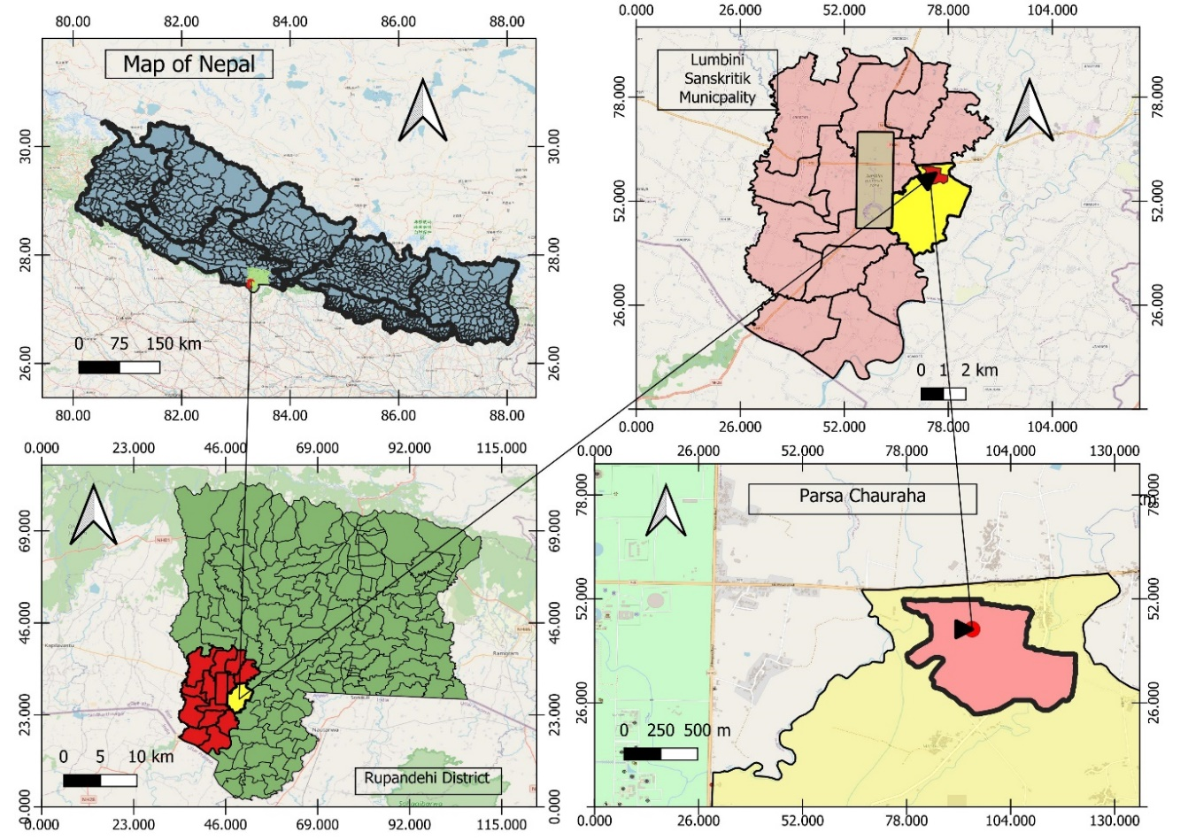

Figure 1: The study area map illustrating Nepal, highlighting the Rupandehi District, specifically focusing on Lumbini Sanskritik Municipality up to Ward 10, and extending to the Parsa Chauraha study area.

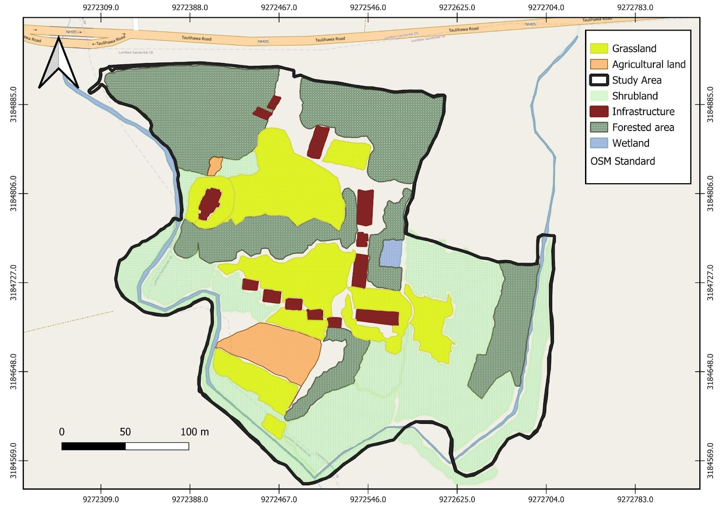

Figure 2: A polygon map of the habitat distribution across the study area

## 3.2. Climate

Lumbini experiences a tropical to subtropical climate with distinct seasons, including long, hot summers and a prolonged monsoon from June to September. Summers often exceed 40 °C, while winters can drop as low as 9 °C, offering a cooler period essential for agriculture. In recent years, temperatures have risen by about 4 °C due to global warming (Baral, 2018, p.24), posing threats to biodiversity and Lepidoptera species. Higher temperatures affect water availability and growing seasons (Malla *et al*., 2022). By conducting the study from 19th February 2024 to 4th March 2024, it will be easier to be able to capture late winter to early spring season shifts and also get some insights into how these insects adapt to environmental changes.

## 3.3. **Vegetation, Flora, Fauna and Habitats**

Lumbini encompasses diverse habitats, including open water bodies (10 ha), forest plantations (270 ha), and grasslands (400 ha) (Baral, 2018, p. 24). LDT has planted rare and endangered native and foreign tree species (Baral, 2018, p. 24). The area supports 72 vascular plant species, mainly from the Asteraceae, Poaceae, and Fabaceae families, with Fabaceae being culturally significant due to its association with Lord Buddha (Bhattarai & Baral, 1970). However, human activities and alien species introductions have led to species decline (Siwakoti, 2008). Key nectar-rich plants include *Vernonia cinerea* and *Helianthus annuus*, while Asteraceae, Lamiaceae, and Moraceae provide essential resources for butterflies. Lumbini is also home to 421 bird species, including the globally threatened Sarus Crane (Baral, 2018, p. 17), as well as mammals like Nilgai, Wild Boar, and Indian Grey Mongoose. The farmlands and Jagadishpur Reservoir are designated as Important Bird and Biodiversity Areas of Nepal (BCN et al., 2023, p. 690).

Interactions between fauna and Lepidoptera create a complex web. Birds, such as Sarus Cranes, act as both competitors and predators, while animals like Nilgai shape plant structures through grazing. Wetlands and aquatic ecosystems, which host various fish species, also affect butterfly life cycles. These relationships underscore the necessity of maintaining a balanced ecosystem to support Lepidoptera populations.

## 3.4. Data collection

A moth trap with a 50W LED light inside a cardboard structure was set up to capture moths at a semi-urban rural site, chosen for its plant variety and proximity to populated areas—factors influencing moth activity. The trap included egg cartons and two glass panes, providing easy entry for moths. The study ran from 19th February to 5th March 2024, with data collection starting at 6:00 P.M. and continuing until 6:30 A.M. Moths collected overnight were photographed in controlled conditions to ensure accurate identification. This approach also allowed for detailed documentation of feeding habits and nocturnal activity.

The tools and sampling procedures were carefully selected to ensure data accuracy and reliability, providing valuable insights into moth ecology in semi-urban areas. Butterfly diversity data was gathered through field surveys and direct observation. On the first day, monitoring occurred from sunrise to sunset, recording butterfly movements and activities hourly to capture temporal variations. Subsequent days focused on peak activity hours from 12:00 PM to 3:00 PM. Surveys covered a 500-meter transect through grasslands, shrublands, wetlands, and forests, with species identified and photographed when possible for accuracy. Weather variables were recorded alongside moth activity to assess correlations. Species identification used digital resources like iNaturalist and field guides by Smith (2010, p.181) and Gurung *et al*. (2024, p.159), with genus-level classification applied when species-level identification was challenging. This rigorous method was followed for at least 14 days to build a robust dataset. Habitat descriptions and dominant plant species were crucial for interpreting both moth trap and butterfly transect results.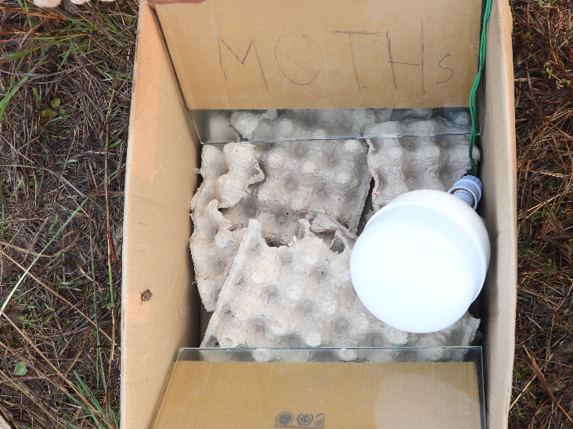 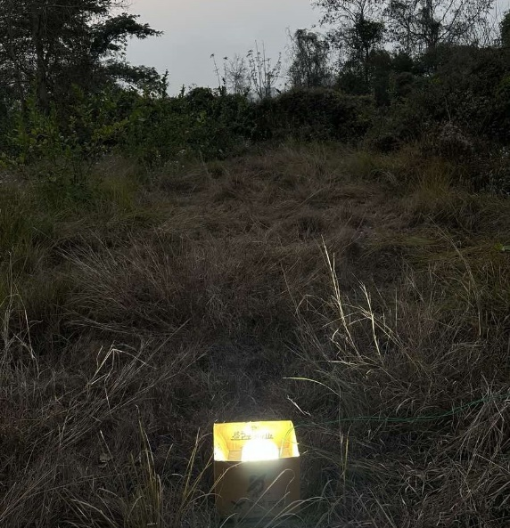

Figure 3: The moth trap and its setting (left). The 50-watt LED light lit up during nighttime (right)

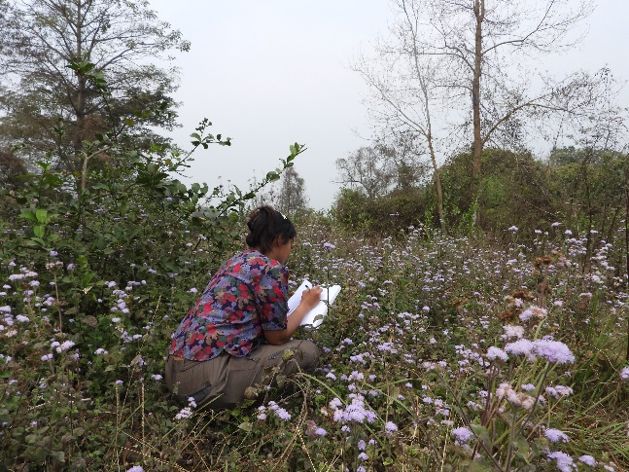 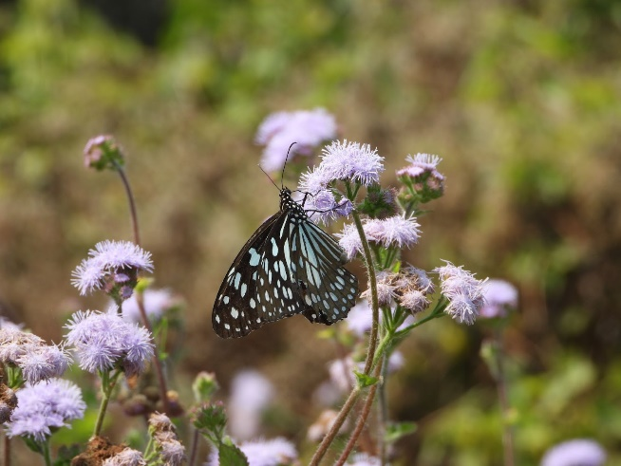

Figure 4: The study was conducted based on observation (left) and observed *Ideopsis vulgaris* (right).

The observed Lepidoptera species were classified into four abundance categories: Very Rare (VR) for 1-2 individuals, Rare (R) for 3-10, Fairly Common (FC) for 11-30, and Common (C) for more than 30 individuals. This systematic classification helps assess species prevalence within the study area (Shrestha *et al*., 2018).

## 3.5. Data analysis

The data was examined using a combination of Microsoft Excel and R Studio for statistical accuracy. Simpson's Diversity Index (D) was used to quantify species diversity, determined by the formula:

**D = 1-(∑ n(n-1)/ N(N-1))**

Where,

n = Number of individuals of a species

N= The total number of individual of all species

D= Simpson’s Diversity Index

This formula measures the likelihood that two randomly selected individuals belong to different species. Index values range from 0 to 1, with higher values indicating higher diversity (Somerfield, Clarke, and Warwick, 2008).

 The Shannon-Wiener Diversity Index (H') was also used to assess both species richness and evenness:

The formula for the Shannon-Weiner Diversity Index (H’) is:

**H’ = Σ S (i=1) Pi*ln (pi)**

Where,

S= Total number of species

pi​ = the proportion of individuals of species iii relative to the total number of individuals (i.e., pi=ni\N , where ni​ is the number of individuals of species i, and N is the total number of individuals)

ln(pi) represents the natural logarithm of 𝑝𝑖. The Shannon-Wiener index accounts for both species richness and evenness, with higher H′ values indicating greater diversity (Bollarapuk *et al*., 2021).

The evenness was calculated to reveal the relative abundance of species distributed using Pielou’s Evenness Index (Equitability) (J’).

The formula for the Pielou’s evenness index (J’) is:

**J’ = H’/ln(S)**

Where,

H′ = Shannon-Wiener diversity index,

S = the total number of species, and

ln(S) = natural logarithm of S.

Pielou's Evenness Index assesses how equally species are distributed among species in a group. It has a range of 0 to 1, with values closer to 1 suggesting more evenly distributed species (Heip, 1974).

Margalef's Richness Index was calculated to measure species richness by adjusting for the total number of individuals obtained, giving an accurate comparison across several habitats.

The formula for the Magalef’s Richness Index (Dmg) is:

**Dmg = S-1/Ln (N)**

Where,

S = Total number of species.

 N = Total number of persons.

ln(N) = The natural logarithm of the total number of species.

Margalef's index quantifies species richness, with higher values reflecting greater richness relative to sample size (Gamito, 2010). R-studio was used to create Rank-abundance (Whittaker) plots for moths and butterflies, while Q-GIS was employed to generate habitat maps.

# Chapter 4: Results

## 4.1. Distribution of the moth family

A total of 30 moth species from six families was observed. The Erebidae family was the most prevalent, representing 44 individuals from various genera, followed by Noctuidae with 29 individuals. Other families, including Geometridae, Crambidae, Pyralidae, and Spilomelinae, had fewer abundances, contributing 5, 4, 3, and 1 individual, respectively. Notably, the Tiger Moth (*Spilosoma strigatula*) of the Erebidae family and the Asiatic Pink Stem Borer (*Sesamia inferens*) of the Noctuidae family were both categorized as FC, with 25 and 18 individuals documented, respectively. A diverse presence of overall diversity and distribution of moth species across different families was revealed.

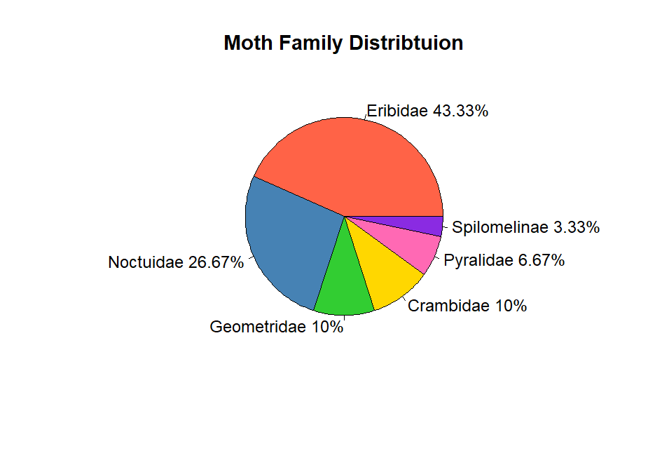

Figure 5: The distribution of moths by the families in percentage

Erebidae was the moth family with the largest percentage, accounting for 43.33% of the total. Next in line were the Noctuidae (26.67%), Geometridae (10%), Crambidae (10%), Pyralidae (6.67%), and Spilomelinae (3.33%).

## 4.2. Rank-Abundance (Whittaker) plot of moth species

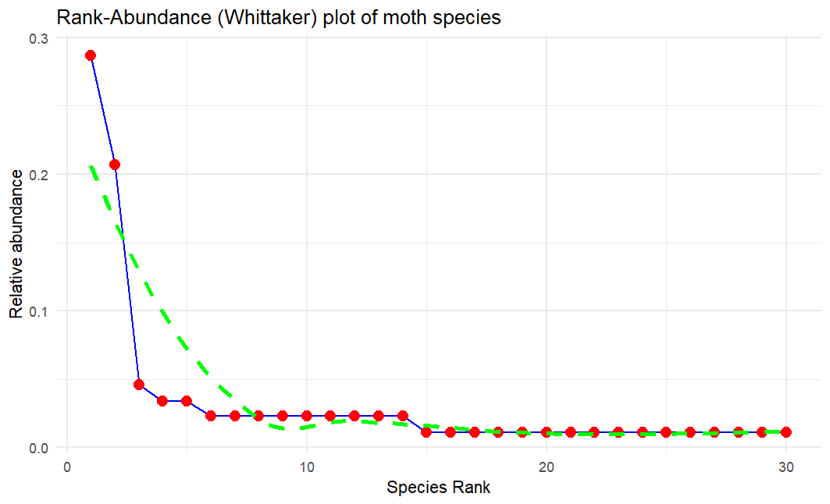

Figure 6: Rank-abundance plot of moth species observed

The Whittaker rank-abundance plot (Figure 6) reveals a community with two dominant moth species, each with relative abundances around 0.3 and 0.23, followed by a sharp decline in abundance. Mid-ranked species show variation, with relative abundances between 0.01 and 0.03, reflecting differing levels of rarity. At the lower end, the plot flattens, indicating several species with similarly low abundances around 0.01, emphasizing the presence of rare species. Overall, the pattern highlights an uneven distribution, with a few dominant species and most others being rare.

## 4.3. Table of diversity indices, richness, and evenness of all of the 6 moth families and their overall total

Table 1: The Shannon-Weiner index (H’); Simpson’s Diversity Index (D); Margalef’s Richness Index (Dmg); Pielou’s Evenness (J’) and Species Richness (S) of all of the 6 families and their overall total

|  |  |  |  |  |  |
| --- | --- | --- | --- | --- | --- |
| **Family** | **H'** | **D** | **Dmg** | **J'** | **S** |
| Eribidae | 1.73 | 0.67 | 3.15 | 0.67 | 13 |
| Noctuidae | 1.36 | 0.59 | 2.08 | 0.66 | 8 |
| Crambidae | 1.04 | 0.63 | 1.44 | 0.95 | 3 |
| Pyralidae | 0.64 | 0.44 | 0.91 | 0.92 | 2 |
| Geometridae | 1.05 | 0.64 | 1.24 | 0.96 | 3 |
| Spilomelinae | 0 | 0 | 0 | 0 | 1 |
| Overall Total | 2.66 | 0.86 | 6.49 | 0.78 | 30 |

Eribidae, contributing 13 species, shows the highest diversity (H' = 1.73), dominance (D = 0.67), and species richness (Dmg = 3.15). Noctuidae, with moderate richness (Dmg = 2.08) and diversity (H' = 1.36), has lower dominance (D = 0.59) and evenness (J' = 0.66). Crambidae and Geometridae exhibit similar diversity and dominance, though Crambidae is more even (J' = 0.95) and Geometridae slightly richer (Dmg = 1.24). Pyralidae has the lowest richness (Dmg = 0.91) and diversity (H' = 0.64), but good evenness (J' = 0.92). Spilomelinae, represented by a single species, lacks diversity indices. The overall community diversity (H') is 2.66, with dominance (D = 0.86) and moderate evenness (J' = 0.78).

## 4.4. Distribution of the butterfly family

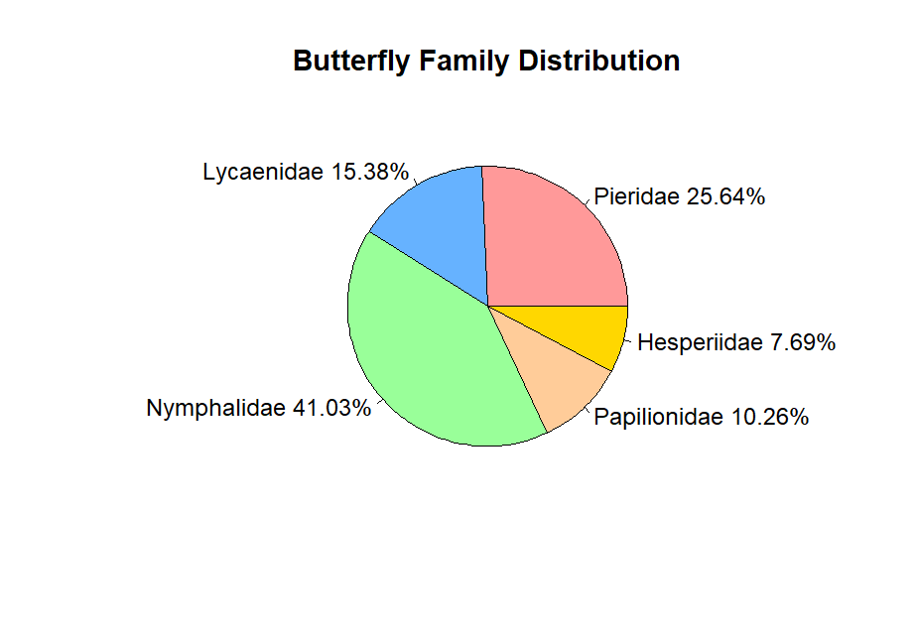

Figure 7: The distribution of the butterflies by the families in percentage

The figure reveals that Nymphalidae was the most dominant butterfly family, comprising 41.03% of the total population, indicating its significant presence across the studied habitats. Following Nymphalidae, Pieridae represented 25.64% of the population, reflecting its relatively high abundance. Lycaenidae accounted for 15.38%, while Papilionidae and Hesperiidae were less prevalent, making up 10.26% and 7.69%, respectively. This distribution suggests that certain families, such as Nymphalidae and Pieridae, are better adapted or more abundant in these habitats, while others maintain a smaller but notable presence.

## 4.5. Rank- Abundance (Whittaker) plot of butterfly species

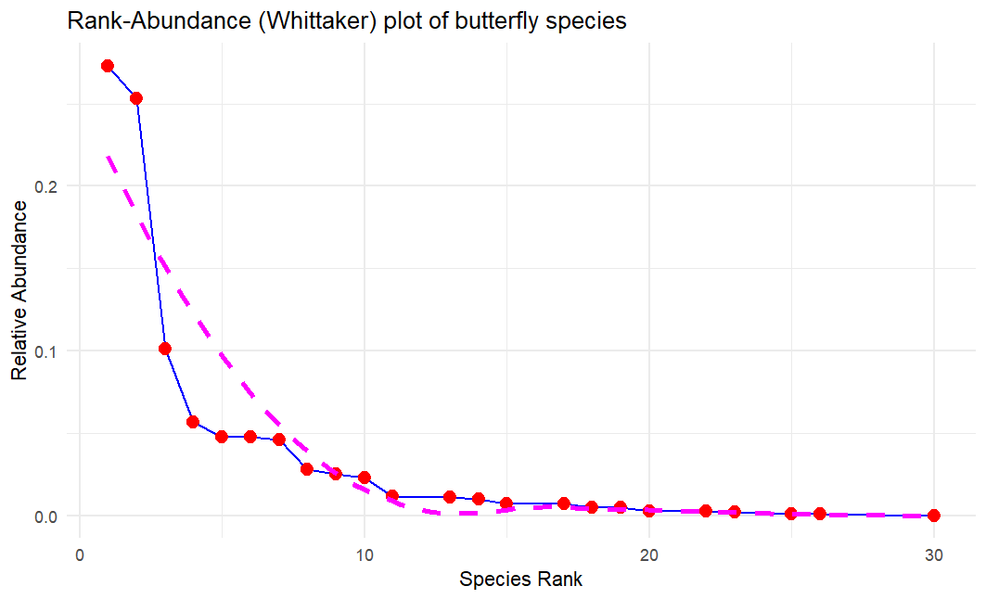

Figure 8: Rank-abundance plot of butterfly species observed

The Rank-Abundance (Whittaker) plot shows that a few butterfly species dominate. After the top five species, abundance drops sharply, and most species beyond rank 10 are rare, contributing little to the total population. The solid line reflects the observed data, showing very rare species than expected, indicating low evenness but high species richness in the community.

## 4.6. Table of diversity indices, richness, and evenness of all of the 5 butterfly families and their overall total

Table 2: The diversity indices calculation of 5 different butterfly families

|  |  |  |  |  |
| --- | --- | --- | --- | --- |
| **Family** | **H'** | **D** | **Dmg** | **J'** |
| Pieridae | 1.398 | 0.611 | 1.309 | 0.607 |
| Lycaenidae | 0.833 | 0.419 | 0.76 | 0.465 |
| Nymphalidae | 1.759 | 0.707 | 2.831 | 0.634 |
| Papilionidae | 0.295 | 0.118 | 0.553 | 0.213 |
| Hesperiidae | 1.099 | 0.667 | 1.82 | 1 |
| Total | 2.317 | 0.839 | 4.962 | 0.633 |

The Nymphalidae family is the most diverse, with the highest Shannon-Wiener index (H' = 1.759), richness (Dmg = 2.831), and evenness (J' = 0.634) among 16 species. Pieridae also shows high diversity (H' = 1.398), richness (Dmg = 1.309), and evenness (J' = 0.607) across 10 species. Hesperiidae, with only 3 species, has perfect evenness (J' = 1), while Lycaenidae and Papilionidae show lower diversity (H' = 0.833 and 0.295) and richness (Dmg = 0.76 and 0.553). Papilionidae has the lowest evenness (J' = 0.213) and 4 species. Overall, the butterfly community is fairly diverse (H' = 2.317) with 39 species.

## 4.7. The family-wise categorization of butterfly richness in 5 different habitats

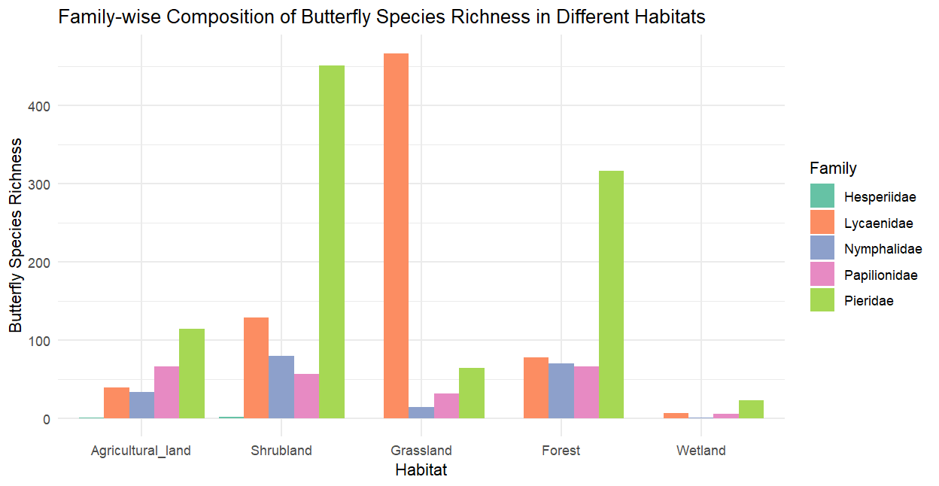

Figure 9: The family-wise categorization of butterfly richness in 5 different habitats

The figure presents a bar graph illustrating the richness of butterfly families across five distinct habitats—agricultural land, shrubland, grassland, forest, and wetlands—encompassing five key families: Hesperiidae, Lycaenidae, Nymphalidae, Papilionidae, and Pieridae. Grassland has the highest species richness, led by Pieridae and Lycaenidae. Shrubland and forest are moderately rich, with Nymphalidae and Pieridae contributing significantly. Agricultural land has lower richness, dominated by Pieridae, while wetlands have the fewest species. Pieridae dominates all habitats except shrubland.  
  
  
  
  
  
4.8. The Shannon Diversity Index and Pielou’s Evenness Index of the Overall Butterfly Richness in 5 different Habitats

Table 3: The Shannon Diversity Index (H’) and Pielou’s Evenness Index of the overall butterfly richness in 5 different habitats

|  |  |  |
| --- | --- | --- |
| **Habitat** | **Shannon Diversity Index (H’)** | **Pielou’s Evenness Index (J)** |
| Agricultural land | 2.0628 | 0.7281 |
| Shrubland | 2.0263 | 0.7010 |
| Grassland | 1.1779 | 0.4463 |
| Forest | 1.7242 | 0.6367 |
| Wetland | 1.4195 | 0.6827 |

Agricultural land shows the highest diversity (H' = 2.0628) and evenness (J = 0.7281), indicating a well-balanced species distribution. Shrubland follows closely with similar diversity (H' = 2.0263) and slightly lower evenness (J = 0.701). Forests display moderate diversity (H' = 1.7242) and evenness (J = 0.6367). Wetlands have fewer species but show balanced composition with high evenness (J = 0.6827) and lower diversity (H' = 1.4195). Grasslands are the least diverse (H' = 1.1779) and even (J = 0.4463), with some species dominating.

4.9: The total vegetation recorded with their origin and the butterfly species that visited the most

Table 4:The total vegetation recorded with their origin and the butterfly species that visited the most

|  |  |  |  |
| --- | --- | --- | --- |
| **S.N.** | **Name of the Vegetation** | **Origin** | **Butterfly species visited** |
| 1 | *Clerodendrum chinense* | Native | *Danaus genutia* |
| 2 | *Trachelospermum jasminoides* | Alien | *Papilio polytes, Pareronia valeriar, Hypolimnas bolina, Danaus genutia, Gonepteryx rhamni, and Papilio demoleus* |
| 3 | *Acmella uliginosa* | Native | *Zizina otis, Oriens gola, Pieris brassicae, Tarucus balcanicus nigra and Castalius rosimon* |
| 4 | *Phyllostachys aurea* | Native | *Junonia almana* |
| 5 | *Pogostemon heyneanus* | Native | *Tarucus balcanicus nigra, Danaus genutia, and Papilio polytes* |
| 6 | *Raphanus raphanistrum* | Planted | *Gonepteryx rhamni, Hypolimnas bolina, Papilio demoleus, and Pieris brassicae* |
| 7 | *Dendrocalamus* | Native | *Danaus genutia, Pachliopta aristolochiae, Cyrestis thyodamas, and Danaus chrysippus* |
| 8 | *Mikania micrantha* | Invasive | *Pieris canidia, Pieris brassicae, Gonepteryx rhamni, Castalius rosimon, Papilio demoleus, and Catopsilia pomona* |
| 9 | *Citrus limon* | Introduced/Planted | *Ideopsis vulgaris, Tirumala limniace, Papilio demoleus, Danaus chrysippus, Papilio polytes,  Catopsilia pomona, Pieris brassicae, Pieris canidia, Borbo cinnara and Gonepteryx rhamni* |
| 10 | *Ageratum houstonianum* | Weed | *Castalius rosimon, Pieris canidia, , Danaus chrysippus and Ideopsis vulgaris* |
| 11 | *Oxalis corniculata* | Weed | *Belenois aurota, Pieris canidia, Pieris brassicae, Eurema brigitta, Eurema hecabe, Tarucus balcanicus nigra* |
| 12 | *Rungia pectinata* | Weed | *Pieris brassicae, Papilio polytes, Castalius rosimon* |
| 13 | *Citrus grandis* | Planted | *Hypolimnas bolina* |
| 14 | *Bidens pilosa* | Weed/ Invasive | *Leptosia nina, Pseudozizeeria maha* |
| 15 | *Evolvulus nummularius* | Weed/ Invasive | *Castalius rosimon* |
| 16 | *Morus nigra* | Planted | *Danaus genutia, Papilio polytes, Ideopsis vulgaris, Papilio clytia, Euploea core, and Danaus chrysippus* |
| 17 | *Lippia alba* | Invasive | *Papilio polytes, Pieris brassicae, Leptosia nina* |
| 18 | *Caryota mitis* | Native | *Moduza procris, Hypolimnas bolina* |
| 19 | *Brassica oleracea* | Planted | *Papilio polytes, Papilio clytia,* and *Tarucus balcanicus nigra* |

The table highlights the relationships between different vegetation types—native, alien, planted, invasive, and weeds—and their influence on butterfly diversity. Native plants like *Clerodendrum chinense* and *Dendrocalamus* attract species such as *Necrophora chinense* and *Pachliopta aristolochiae.* Invasive plants, including *Mikania micrantha*, are preferred by butterflies like *Papilio polytes* and *Hypolimnas bolina*. Planted species, such as *Citrus limon*, attract butterflies like *Gonepteryx rhamni*, while weeds like *Oxalis corniculata* are favored by species like *Pieris brassicae*. This shows a complex interaction between plant types and butterfly species.

# Chapter 5: Discussion

Considering the time of the year and the limited timeframe for the study, the identification of 30 moth species from six families, covering 26 unique genera, and 39 butterfly species from five families, spanning 31 genera, within just 14 days in a small area, highlights a very rich Lepidoptera diversity.

### **5.1 Family Dominance and Diversity of Moth Species**

The Eribidae family was the most dominant, comprising 55.32% of all families recorded (Figure 5), with 13 different species identified, including *Spilosoma strigatula*, *Asura-miltochrista* group sps, *Dasychira*, *Ericeia inangulata*, *Cretonotos transiens, Spilosoma obliqua, Eressa confinis, Spilosoma* *(*genera spp.1*), Spilosoma* (genera spp.2), *Lymantria ampla, Spilarctica* (genera spp.), *Creatonotos gangis-interrupta,* and *Pandesma* (genera spp.). With a Simpson's Diversity Index (D) of 0.67 and a Shannon-Weiner Index (H') of 1.73, the Eribidae family has the highest level of diversity, suggesting that its 13 species are distributed evenly throughout the family. It also has the highest species richness (Dmg = 3.15) (Table 2). These findings are consistent with previous studies, such as those by Sondhi *et al.* (2018), at Shendurney and Ponmudi in Kerala, India's Agastyamalai Biosphere Reserve, where Eribidae was also identified as the most abundant moth family. Similarly, Ahmed *et al.* (2024) reported that Eribidae was among the most commonly recorded moth families in the Mahamaya Reserve Forest in Assam. Following Eribidae, the Noctuidae family accounted for 29.79% of the moth species, with 8 different species recorded. Noctuidae is less diverse than Eribidae but makes a major contribution to the community, as evidenced by its moderate diversity (H' = 1.36, D = 0.59) and richness (Dmg = 2.08) (Table 2). Other recorded families include Geometridae and Crambidae, each representing 5.32% of the total. Although these families have fewer species, they are evenly spread, as shown by their lower diversity (H' = 1.04, 1.05) but high evenness (J' = 0.95, 0.96). Pyralidae, with 3.19% of the population and two species, show the lowest diversity (H' = 0.64) but the highest evenness (J' = 0.92), indicating a balanced but small representation. Spilomelinae, represented by just one species at 1.06%, shows no diversity or evenness. Overall, the community is diverse, with a high Shannon-Weiner Index (H' = 2.66) and 30 species, indicating a rich moth assemblage despite varying contributions from families. *Spilosoma strigatula* (25 individuals) and *Sesamia inferens* (18 individuals) were the most abundant species. The dominance of *S*. *strigatula* aligns with Sanyal *et al.* (2013), who noted it as a major agricultural pest and a detector species. The current study, conducted from late winter to early spring (19th February to 5th March), parallels findings from the Western Himalayas across three seasons, suggesting seasonal timing influences species abundance. In contrast, Dubey and Dubey (2019) reported different results, attributed to variations in methodology, timing, habitat, or incomplete regional moth population knowledge.

### **5.2. Species Adaptation in Semi-Urban Agricultural Land: Moths in a Lemon Farm**

Some families, such as the Erebidae and Noctuidae, appear to be more adapted to the environment of the lemon farm and its surrounding plants, as evidenced by their dominance in the recordings (Appendix 1). The recording of the moths might have been highly influenced by the habitat that it was conducted in, which was a semi-urban agricultural land/grassland consisting of a lemon farm with excessive growth of native/alien vegetation like *Imperata cylindrica* and *Mikania micrantha.* So, the moth species may have adapted to the altered plant ecology—which does well in disturbed or semi-natural habitats (Merckx, 2015). Likewise, several moths may choose certain habitats and food supplies provided by the natural grass species *Imperata cylindrica*. Consequently, the moth species that have been observed are probably either generalists, which can survive in disturbed environments like farmland, or specialists, which have adapted to the specific flora that is present (Kadlec *et al*., 2009).

### **5.3. Influence of Weather patterns, Lunar phase, Light Traps, and Nocturnal Habits**

The presence of the moth species that have been seen may have been impacted not only by the environment but also by varying weather patterns. When a full moon fell on February 24, 2024, for instance, fewer moth species may have been detected than on February 25, when only one species was noted. According to Williams and Singh (1951), when strong lights are used to attract insects at night, the number of species captured is substantially more during the new moon than it is during the full moon. This is because when there is no moonlight during a new moon, artificial light is more appealing to insects, but when there is a full moon, artificial light is less effective and attracts fewer insects. A termite swarm with complete cloud cover on February 27, 2024, in contrast to a full moon, resulted in a larger diversity of moths being reported, with seven distinct species being spotted. Watkins (2024) found a positive correlation between more cloud cover and more moth activity. This is probably because clouds may cover natural light sources like moonlight, which makes the light traps stand out and attracts moths looking for a dependable source of light during the dark (Nowinszky, 2010).

### **5.4. Status and Abundance Patterns of Moth Species**

The status and abundance of the total moth species, classified according to their families, are detailed comprehensively in the accompanying data (Appendix 1), offering insight into their distribution patterns and prevalence. Analyzing the moths by status reveals that most individuals belong to the Fairly Common (FC) and Very Rare (VR) categories. A few FC species, like *Spilosoma strigatula* and *Sesamia inferens*, make up a significant portion of the total, indicating their role as well-established pests with important ecological impacts. In contrast, most species are classified as VR but contribute far less to the overall population, likely due to their restricted distribution and specialized habitat needs. FC species, with their broader ecological niches and adaptability, have a more prominent presence in the ecosystem (MacArthur & Wilson, 2001). Very Rare (VR) species like *Cretonotos transiens* often have specialized needs, resulting in limited distributions and smaller populations, highlighting their role in preserving genetic and ecological diversity but also their vulnerability to environmental changes (Thomas, 2004). Rare (R) species, such as those from the *Asura-miltochrista*, have moderate representation, indicating they are less common than FC species but still play a significant role. While a few common species dominate, the presence of many rarer species adds ecological complexity, emphasizing the importance of habitat preservation for sustaining biodiversity.

### **5.5. Factors Influencing the Moth Species Dominance and Distribution in Rank Abundance Plot**

Several environmental factors likely contribute to the rank abundance pattern observed (Figure 6), where a few dominant moth species are much more common than others. The most abundant species show a relative abundance of around 0.28 which are *Spilosoma strigatula* and *Sesamia inferens*, while the least abundant species drop to 0.01 with species such as *Sameodes cancellalis*, *Uresiphita*- genera sps and *Pandesma* -genera sps. Environmental conditions, such as temperature, humidity, and vegetation, may favor certain species, leading to their dominance in the study area (Highland, Miller, and Jones, 2013). Dominant species may have a competitive edge due to life history traits such as higher reproduction rates, broader feeding preferences, or better adaptation to the local environment (Slade *et al*., 2013). Additionally, abundance shifts could be influenced by certain species being more attracted to the light trap due to their nocturnal behavior or increased sensitivity to light (Truxa and Fiedler, 2012). Species near the lower end of the rank-abundance curve may be rarer or more specialized, accounting for their lower presence in the sample (Chey, Holloway, and Speight, 1997). The unequal distribution of abundances in the plot likely results from environmental suitability, competitive advantages, and potential sampling bias.

### **5.6. Species Richness and Diversity of Butterfly Families**

The Nymphalidae family had the highest species richness (41.03%) (Figure 7), with the greatest diversity (H' = 1.759), Margalef richness (Dmg = 2.831), and evenness (J' = 0.634) (Table 1), covering 16 species like *Danaus genutia* (C), *Hypolimnas bolina* (FC), and several VR species such as *Junonia almana*. Pieridae (25.64%) followed with 10 species, including *Cepora nerissa* (FC) and *Pieris brassicae* (C). Lycaenidae (15.38%) included 6 species, such as *Zizina otis* (C). Papilionidae (10.26%) had 4 species, led by *Papilio polytes* (C), while Hesperiidae (7.69%) recorded 3 VR species. The data reveal a diverse butterfly community, with common species like *Pieris brassicae* thriving and very rare species like *Junonia almana* and *Eurema hecabe* showing limited distribution, accounting for around 5.88% of butterflies found in Nepal. A similar dominance was observed in Thakurbaba Municipality, Bardiya, in the lowlands of Western Nepal, where Nymphalidae also had the highest species richness (Paudel, Shah, and Bashyal, 2024). Similarly, Sharma and Paudel (2021) found that Nymphalidae dominated species richness with 31 species in Kumakh Rural Municipality, Salyan District, Nepal. Despite varied geography and climate in the Manang Region, Shrestha *et al.* (2020) also observed Nymphalidae as the most species-rich family. This dominance is likely due to their adaptability to various habitats, diverse larvae host plants, and high reproductive rates, allowing them to thrive in both tropical and temperate regions (Khyade, Gaikwad, and Vare, 2018).

### **5.7. Rank-Abundance Analysis of Butterfly Species: Patterns of Dominance**

The Rank-Abundance plot of butterfly species (Figure 8) reveals a community where a few species dominate with high relative abundances such as the , while many others are rare. This pattern suggests a diverse ecosystem, where dominant species likely thrive due to better adaptation to environmental conditions or greater resilience to change. The steep decline in relative abundance followed by a gradual slope highlights the presence of both common and rare species, highlighting the ecosystem's complexity and richness, and emphasizing the need to protect these rare species to maintain biodiversity and resilience. *Pieris canidia* (C)was the most abundant butterfly species, comprising 27.29% of all individuals, closely followed by *Zizina otis* (C)at25.31% (Figure 4)*.* Shrestha *et al.* (2018)also identified *Pieris canidia* as the most abundant species, with *Aglais cashmerensis* as the second. However, *Aglais cashmerensis* was not recorded in this study, likely because it was still hibernating. According to Riyaz and Sivasankaran(2021), this species hibernates from December to February in sheltered locations, becoming active in March as temperatures rise, which may explain the timing of the current study.

### **5.8. Habitat Influence on Butterfly Species Richness and Diversity**

 Grassland exhibits the highest species richness, particularly in the Lycaenidae and Pieridae families (Figure 6), while agricultural land and shrubland demonstrate the greatest species diversity, with values of 2.0628 and 2.0263, respectively, compared to grassland's 1.1779 (Table 3). Agricultural land and wetlands also show the highest species evenness at 0.7281 and 0.6827, while grassland has the lowest at 0.4463. The abundance of Lycaenidae and Pieridae in grassland and shrubland is tied to their unique ecological conditions. Grasslands offer ample nectar and host plants, providing the sunny environments essential for Pieridae butterflies like *Eurema brigitta* and *Leptosia nina*, which rely on plants such as *Oxalis corniculata* and *Lippia alba* (Table 4). Similarly, Lycaenidae species like *Zizina otis* and *Castalius rosimon* thrive in shrublands, benefiting from diverse plant life, including *Acmella uliginosa* and *Rungia pectinata*. These habitats support various microhabitats, allowing diverse species within these families to coexist and flourish, contributing to the observed high species richness (Alsterberg *et al*., 2017). The high species diversity in agricultural land and shrubland reflects a well-balanced community with many species distributed evenly, promoting ecological stability and biodiversity. This distribution of butterfly species across habitats highlights the significant role of plant communities in influencing their abundance.

### **5.9. Influence of vegetation across habitats affecting the overall diversity of butterflies**

Agricultural and shrub areas, with diverse plant species such as *Raphanus raphanistrum, Citrus limon, Citrus grandis, Morus nigra, Clerodendrum chinense, Trachelospermum jasminoides, Pogostemon heyneanus,* and *Ageratum houstonianum*, offer abundant nectar and food sources. This plant diversity promotes a high abundance and richness of butterflies, highlighting the importance of plant diversity for supporting healthy butterfly populations. Similar findings by Tiple and Khurad (2012) in Nagpur, Central India, showed that agricultural land supports a wider variety of species compared to grasslands. In contrast, studies by Paudel, Shah, and Bashyal (2024) found that forest habitats had the highest species diversity, while farmland had the lowest. The current research may differ because the farmland was free of harmful pesticides, attracting a wider variety of species. *Pieris canidia*, *Papilio polytes*, *Pieris brassicae*, and *Castalius rosimon* were the most frequent species across habitats, likely due to their adaptation to semi-urban areas, the abundance of suitable host plants from families like Brassicaceae and Rutaceae, and their rapid reproductive rates (Kitashiba and Nasrallah, 2014). Their diverse feeding habits on readily available nectar sources also support their survival. According to Priyadarshana *et al.* (2023), *Pieris canidia* and *Pieris brassicae* thrive in farmlands as important pests of cruciferous crops. Intensive agricultural techniques and landscape simplification create favorable conditions for these pests, with fewer natural predators and ample food supplies. Additionally, field edges and blooming weeds provide extra nutrients and habitat, further increasing their abundance (Curtis *et al*., 2015).

These findings in Lumbini underscore the complex relationships between Lepidoptera species and their habitats, emphasizing the significance of plant diversity and environmental conditions in shaping these populations. The dominance of the Nymphalidae family across Nepal and the rich diversity of moths in Lumbini's farmlands illustrate the substantial impact of habitat variation and management on species composition. Additionally, the adaptation of families like Erebidae and Noctuidae in disturbed environments highlights these species' resilience to environmental changes.

|  |
| --- |
|  |
|  |
|  |

# Chapter 6: Conclusion

The findings reveal a rich and diverse assemblage of Lepidoptera species, highlighting differences in family representation, species abundance, and diversity. Among moths, the Erebidae family was the most abundant, followed by Noctuidae, while butterflies were dominated by the Pieridae and Lycaenidae families, particularly in grassland and shrubland habitats. These patterns underscore the distinct ecological roles and behaviors of butterflies and moths, influencing their species richness, evenness, and diversity. Butterflies, being diurnal and often more specialized, exhibited lower species richness and evenness, with certain species dominating due to factors like host plant availability and seasonal trends. Moths, being predominantly nocturnal and more generalist, exhibited higher species richness and evenness, occupying a wider range of ecological niches and showing greater adaptability to seasonal changes. The diversity indices reveal variations across families and habitats, with some areas supporting more balanced species distributions. The study emphasizes the strong link between plants and butterfly species, illustrating how habitat and vegetation shape diversity and distribution. These findings enhance our understanding of the region's biodiversity and ecological dynamics, highlighting the role of habitat in structuring moth and butterfly communities. The observed species fluctuations also underscore the need for ongoing monitoring to better understand the ecological processes affecting these populations.

# Chapter 7: Recommendations

Extending timeframes to collect more precise seasonal data would significantly improve studies on Lepidoptera diversity, especially for butterflies, whose abundance is shaped by seasonal fluctuations. Detailed habitat studies on moths can offer key insights into their ecological preferences, while regular multi-season monitoring will capture changes in species richness and evenness, enhancing our understanding of habitat dynamics. Integrating habitat conservation with sustainable land-use practices is essential to sustaining biodiversity and supporting moth and butterfly populations. Advanced species categorization techniques will minimize identification errors, ensuring more accurate data on moth diversity. Additionally, preserving diverse habitats such as shrublands, wetlands, forests, and flowering areas can attract both butterflies and moths, with the potential to recommend specific plants for public gardens. Education efforts, particularly in schools, alongside initiatives like butterfly or moth houses, can raise awareness, support conservation, and promote ecotourism.

# Reference list

Acharya, B.K. and Vijayan, L. (2015) Butterfly diversity along the elevation gradient of Eastern Himalaya, India. *Ecological Research* [online]. **30**(5), pp.909–919. Available from doi:https://doi.org/10.1007/s11284-015-1292-0. [Accessed 3rd July 2024]

Ahmad Dar, A., Jamal, K., Alhazmi, A., El-Sharnouby, M., Salah, M. and Sayed, S. (2021) Moth diversity, species composition, and distributional pattern in Aravalli Hill Range of Rajasthan, India. *Saudi Journal of Biological Sciences* [online]. **28**(9), pp.4884–4890. Available from doi: <https://doi.org/10.1016/j.sjbs.2021.06.018>. [Accessed 20th Mar. 2024]

Ahmed, G., Das, A. N., Borah, L. and Ahmed, R. (2024) Moth Diversity in the Mahamaya Reserve Forest, Kokrajhar, Assam. *Indian Journal of Entomology* [online]. pp.1–5. Available from:https://doi.org/10.55446/ije.2024.1337. [Accessed 18th May 2024]

Alsterberg, C., Roger, F., Sundbäck, K., Juhanson, J., Hulth, S., Hallin, S. and Gamfeldt, L. (2017) Habitat diversity and ecosystem multifunctionality—The importance of direct and indirect effects. *Science Advances* [online]. **3**(2), p.e1601475. Available from: https://doi.org/10.1126/sciadv.1601475. [Accessed 23rd Aug. 2024]

Baral, H. S. (2018) Natural History of Lumbini Farmscape: Central Lowland Nepal. 1st ed. Kathmandu: Himalayan Nature, P.184. [Accessed 18th April. 2024]

BCN, DNPWC, and DoFSC (2023) Important Bird and Biodiversity Areas in Nepal key sites for conservation. Kathmandu: Bird Conservation Nepal, Department of National Parks and Wildlife Conservation, and Department of Forest and Soil Conservation. [Accessed 17 Feb. 2024]

Bhattarai, K.R. and Baral, S.R. (1970) Potential role of sacred grove of Lumbini in biodiversity conservation in Nepal. Banko Janakari [online]. **18**(1), pp.25–31. Available from: https://doi.org/10.3126/banko.v18i1.2163. [Accessed 20 Mar. 2024]

Bollarapuk, M.J., Ramarao, V.S.N., Kshirsgar, P. and Singla, J. (2021) Biodiversity Measures Mathematical Evaluation of Various Indices. *Researchgate.net* [online] pp.46–59. Available from: https://www.researchgate.net/publication/354495338_BIODIVERSITY_MEASURES_-MATHEMATICAL_EVALUATION_OF_VARIOUS_INDICES [Accessed 8th Sep. 2024].

Chen, X., Wang, Z., Zhang, C., Hu, J., Lu, Y., Zhou, H., Yang, M., Cong, Y., Guo, F., Wang, Y., He, K., Liu, Y. and Li, F. (2023) Unraveling the complex evolutionary history of lepidopteran chromosomes through ancestral chromosome reconstruction and novel chromosome nomenclature. *BMC Biology* [online]. **21**(1). Available from: https://doi.org/10.1186/s12915-023-01762-4. [Accessed 15th Aug. 2024].

Chey, V.K., Holloway, J.D. and Speight, M.R. (1997) Diversity of moths in forest plantations and natural forests in Sabah. *Bulletin of Entomological Research* [online]. **87**(4), pp.371–385. Available from: https://doi.org/10.1017/s000748530003738x. [Accessed 19th Sep. 2024].

Choudhary, N.L. and Chishty, N. (2020) Effect of habitat loss and anthropogenic activities on butterflies' survival: A review. *Researchgate.net* [online]. **5**(4), pp.94–98. Available from: https://www.researchgate.net/publication/343648282_Effect_of_habitat_loss_and_anthropogenic_activities_on_butterflies_survival_A_review [Accessed 8th Aug. 2024].

Crossley, M.S., Smith, O.M., Berry, L.L., Phillips‐Cosio, R., Glassberg, J., Holman, K.M., Holmquest, J.G., Meier, A.R., Varriano, S.A., McClung, M.R., Moran, M.D. and Snyder, W.E. (2021) Recent climate change is creating hotspots of butterfly increase and decline across North America. *Global Change Biology* [online]. **27**(12), pp.2702–2714. Available from: https://doi.org/10.1111/gcb.15582. [Accessed 23rd Aug. 2024].

Cunningham, J.P. and Zalucki, M.P. (2014) Understanding heliothine (Lepidoptera: Heliothinae) pests: what is a host plant? *Journal of Economic Entomology* [online]. **107**(3), pp.881–896. Available from: https://doi.org/10.1603/ec14036. [Accessed 5th Aug. 2024].

Curtis, R.J., Brereton, T.M., Dennis, R.L.H., Carbone, C. and Isaac, N.J.B. (2015) Butterfly abundance is determined by food availability and is mediated by species traits. *Journal of Applied Ecology* [online]. **52**(6), pp.1676–1684. Available from: https://doi.org/10.1111/1365-2664.12523. [Accessed 20th Aug. 2024].

Dar, A. and Jamal, K. (2021) The Decline of Moths Globally: a Review of Possibly Causes. *Munisentzoo* [online]. pp.317–326. Available from: https://www.munisentzool.org/yayin/Vol_16/Issue_1/20201224-LH1PVQQ8.pdf [Accessed 15th Apr. 2024].

Dewan, A. and Shrestha, B.R. (2021) Moths of Sub-alpine Zone of Gaurishankar Conservation Area, Nepal. *Researchgate.net* [online] Available from: https://www.researchgate.net/publication/356786866_MOTHS_OF_SUB-ALPINE_ZONE_OF_GAURISHANKAR_CONSERVATION_AREA_NEPAL [Accessed 8th Aug. 2024].

Dubey, S. and Dubey, A.K. (2019) Moths (Insecta: Lepidoptera) of Prayagraj, Uttar Pradesh. *International Journal of Global Science Research* [online]. **6**(2). Available from: <https://doi.org/10.26540/ijgsr.v6.i2.2019.137>. [Accessed 19th May. 2024].

Fitzmaurice, A., Poudel, P., Offord-Woolley, S., Macdonald, D., Thapa, S., Lamichhane, B.R., Baral, A. and Yadav, B.P. (2021) Complex consequences of conservation success: Emerging human-tiger conflicts in Nepal. *CatNews* [online]. Available from: https://ora.ox.ac.uk/objects/uuid:aa7a2d60-1dde-4fb2-8561-0bb8a87d7379 [Accessed 12th Jul. 2024].

Fox, R. (2012) The decline of moths in Great Britain: a review of possible causes. *Insect Conservation and Diversity* [online]. **6**(1), pp.5–19. Available from: <https://doi.org/10.1111/j.1752-4598.2012.00186.x>. [Accessed 28th June. 2024].

Gamito, S. (2010) Caution is needed when applying Margalef diversity index. *Ecological Indicators* [online]. **10**(2), pp.550–551. Available from: https://doi.org/10.1016/j.ecolind.2009.07.006. [Accessed 2nd May. 2024].

Gaudel, P., Paudel, M., Gaudel, P., Giri, B.R. and Shrestha, B.R. (2020) Mortality Census of the Road-Killed Butterflies in Mahendra Highway, Nepal. *Journal of Insect Biodiversity and Systematics* [online]. **6**(1), pp.87–99. Available from:https://doi.org/10.52547/jibs.6.1.87. [Accessed 28th Aug. 2024].

Gibb, T. (2015) Chapter 4 - Insect Identification Techniques. *ScienceDirect* [online]. Available from: <https://www.sciencedirect.com/science/article/abs/pii/B9780124046238000041>. [Accessed 7th April. 2024].

Goldstein, P.Z. (2017) Diversity and Significance of Lepidoptera: A Phylogenetic Perspective. *Insect Biodiversity* [online]. pp.463–495. Available from: <https://doi.org/10.1002/9781118945568.ch13>. [Accessed 23rd Aug. 2024].

Gunathunga, P., Dangalle, C.D. and Pallewatta, N. (2022) Diversity and Habitat Preferences of Moths (Insecta: Lepidoptera) in Indikadamukalana, a Lowland Wet Zone Forest in Sri Lanka. *Journal of Tropical Forestry and Environment* [online]. **12**(01). Available from: <https://doi.org/10.31357/jtfe.v12i01.6109>. [Accessed 20th Aug. 2024].

Gurule, S. and Nikam, S.M. (2011) Inventory of Lepidopterous Insects In North Maharashtrya And Survey For Moth Diversity. *Researchgate.net* [online] Available from: https://www.researchgate.net/publication/215451305_INVENTARY_OF_LEPIDOPTEROUS_INSECTS_IN_NORTH_MAHARASHTRA_AND_SURVEY_FOR_MOTH_DIVERSITY [Accessed 13th Aug. 2024].

Gurung, T.B., Pokharel, K.P., and Magar, K.T. (2024) Field Guide Butterflies of Chitwan, Nepal. 1st ed. Chitwan: Kalika Printing, P.159. [Accessed 18th April. 2024].

Haruta, T. (1992) Moths of Nepal- Part 1. *The Japan heterocerists’ society* [online]. p.170. Available from: http://www.moth.jp/wp/wp-content/uploads/2019/01/Moths-of-Nepal-part-1.pdf [Accessed 28th Jul. 2024].

Haruta, T. (1993) Moths of Nepal. *The Japan heterocerists’ society* [online]. **13**(2), pp.1–207. Available from: http://www.moth.jp/wp/wp-content/uploads/2019/01/Moths-of-Nepal-part-2.pdf [Accessed 10th Aug. 2024].

Heip, C. (1974) A New Index Measuring Evenness. *Journal of the Marine Biological Association of the United Kingdom* [online]. **54**(3), pp.555–557. Available from: <https://doi.org/10.1017/s0025315400022736>. [Accessed 19th Apr. 2024].

Highland, S.A., Miller, J.C. and Jones, J.A. (2013) Determinants of moth diversity and community in a temperate mountain landscape: vegetation, topography, and seasonality. *Ecosphere* [online]. **4**(10), pp.129. Available from: <https://doi.org/10.1890/es12-00384.1>. [Accessed 10th Aug. 2024].

Iqbal, W., Faheem Malik, M., Hussain, M., Ashraf, H., Kaleem Sarwar, M., Azam, I. and Umar, M. (2016) Butterfly diversity; district Gujrat, Punjab, Pakistan. *International Network for Natural Sciences Research Journal* [online]. Available from: https://innspub.net/butterfly-diversity-district-gujrat-punjab-pakistan/ [Accessed 2nd Sep. 2024].

Jennersten, O. (1984) Flower visitation and pollination efficiency of some North European butterflies. *Oecologia* [online]. **63**(1), pp.80–89. Available from:https://doi.org/10.1007/bf00379789. [Accessed 6thAug. 2024].

Jnawali, S., Baral, H.S., Lee, H., Acharya, K.P., Upadhyay, G., Pandey, M., Shrestha, R., Joshi, D., Lamichhane, B.R., Griffiths, J., Khatiwada, A.P., Subedi, N. and Amin, R. (2011) The Status of Nepal’s Mammals: The National Red List Series Compilers. *IUCN*.org [online]. Available from: https://www.ntnc.org.np/sites/default/files/doc_publication/2018-11/The%20Status%20of%20Nepal%27s%20Mammals%20-%20Red%20List.pdf [Accessed 8 May 2024].

Kadlec, T., Kotela, M., Novák, I., Konvička, M. and Jarošík, V. (2009) Effect of land use and climate on the diversity of moth guilds with different habitat specialization. *Community Ecology* [online]. **10**(2), pp.152–158. Available from: <https://doi.org/10.1556/comec.10.2009.2.3>. [Accessed 20th Aug. 2024].

Katumo, D.M., Liang, H., Ochola, A.C., Lv, M., Wang, Q.-F. and Yang, C.-F. (2022) Pollinator diversity benefits natural and agricultural ecosystems, environmental health, and human welfare. *Plant Diversity* [online]. **44**(5). Available from: <https://doi.org/10.1016/j.pld.2022.01.005>. [Accessed 25th Aug. 2024].

Khanal, B. (2007) The Late Season Butterflies of Koshi Tappu Wildlife Reserve, Eastern Nepal. *Our Nature* [online]. **4**(1), pp.42–47. Available from: [https://doi.org/10.3126/on.v4i1.501. [Acessed](https://doi.org/10.3126/on.v4i1.501.%5bAcessed) 13th Sept. 2024]

Khanal, B. (2013) Study on Changes in Butterfly Fauna at Different Altitudinal Levels in Central Nepal. *Mzuir.inflibnet* [online] Available from: https://mzuir.inflibnet.ac.in/bitstream/123456789/149/1/Bhaiya%20Khanal%20(Zoology)%20-%202013.pdf [Accessed 6th Aug. 2024].

Khanal, B. and Shrestha, B.R. (2022) Diversity, distribution and medical significance of Gazalina species (Lepidoptera: Notodontidae) in Nepal. *Nepalese Journal of Zoology* [online]. **6**(S1), pp.45–49. Available from: <https://doi.org/10.3126/njz.v6is1.50529>. [Accessed 24th Aug. 2024].

Khanal, B. and Smith, C. (1997). *Butterflies of Kathmandu Valley*. 1st ed. Bangkok, Thailand: TAC Press. [Accessed 26th Aug. 2024].

Khyade, V.B., Gaikwad, P.M. and Vare, P.R. (2018) Explanation of Nymphalidae Butterflies. *International Academic Journal of Science and Engineering* [online]. **5**(2), pp.87–110. Available from: https://doi.org/10.9756/iajse/v5i1/1810029. [Accessed 12th Aug. 2024].

Kitashiba, H. and Nasrallah, J.B. (2014) Self-incompatibility in Brassicaceae crops: lessons for interspecific incompatibility. Breeding Science [online]. **64**(1), pp.23–37. Available from: https://doi.org/10.1270/jsbbs.64.23. [Accessed 13th Aug. 2024].

Kwon, T.-S., Lee, C.M., Kim, E.-S., Won, M., Kim, S.-S. and Park, Y.-S. (2021) Habitat change has greater effects than climate change on butterfly occurrence in South Korea. *Global Ecology and Conservation* [online]. **26**, p.e01464. Available from: <https://doi.org/10.1016/j.gecco.2021.e01464>. [Accessed 12th Aug. 2024].

MacArthur, R.H. and Wilson, E.O. (2001) The Theory of Island Biogeography. *Princeton University Press* [online]. Available from: <https://doi.org/10.1515/9781400881376>. [Accessed 19th Aug. 2024].

Macgreggor, C.J., Pocock, M.J.O., Fox, R. and Evans, D.M. (2014) Pollination by nocturnal Lepidoptera, and the effects of light pollution: a review. *Ecological Entomology* [online]. **40**(3), pp.187–198. Available from: https://doi.org/10.1111/een.12174. [Accessed 13th Aug. 2024].

Malla, S., Bista, L., Rosyara, U and Sapkota, B. (2022) Effect of unseasonal rainfall on rice production in Nepal during the year 2021: A case study. *Archives of agriculture and environmental science* [online]. **7**(2), pp.294–299. Available from: https://doi.org/10.26832/24566632.2022.0702020. [Accessed 13th Aug. 2024].

Merckx, T. (2015) Rewilding: Pitfalls and Opportunities for Moths and Butterflies. *Rewilding European Landscapes* (online). pp.107–125. Available from: <https://doi.org/10.1007/978-3-319-12039-3_6>. [Accessed 16th Aug. 2024].

Miya, M.S., Chhetri, A., Gautam, D. and Omifolaji, J.K. (2021) Diversity and abundance of butterflies (Lepidoptera) in Byas municipality of the Tanahun district, Nepal. *Journal of Crop Protection* [online]. **10**(4), pp.685–700. Available from: https://jcp.modares.ac.ir/article-3-53530-fa.html [Accessed 8th Aug. 2024].

New, T.R. (1997) Are Lepidoptera an effective ‘umbrella group‘for biodiversity conservation? *Journal of Insect Conservation* [online]. **1**(1), pp.5–12. Available from: <https://doi.org/10.1023/a:1018433406701>. [Accessed 13th Aug. 2024].

New, T.R. (2004) Moths (Insecta: Lepidoptera) and conservation: background and perspective. *Journal of Insect Conservation* [online]. **8**(2/3), pp.79–94. Available from: <https://doi.org/10.1023/b:jico.0000045807.04047.bd>. [Accessed 5th June. 2024].

Nowinzky, L. (2010) Light Trapping As a Dependent Of Moonlight And Clouds. *Applied Ecology and Environmental Research* [online]. **8**(4), pp.301–312. Available from :https://doi.org/10.15666/aeer/0804_301312. [Accessed 10th Sept. 2024].

Oli, B.R. and Sharma, M. (2019) Butterfly Species Richness in T.U. Collage Area, Kirtipur, Kathmandu, Nepal. *Researchgate.net* [online] **2**(1), pp.35–42. Available from: https://www.researchgate.net/profile/Buddhi-Oli/publication/350727021_Butterfly_Species_Richness_in_TU_Collage_Area_Kirtipur_Kathmandu_Nepal/links/606edb39a6fdcc5f778d214e/Butterfly-Species-Richness-in-TU-Collage-Area-Kirtipur-Kathmandu-Nepal.pdf [Accessed 8th Aug. 2024].

Owada, M. (1981) A New Moth of the Genus Lophotyna (Noctuidae: Amphipyrinae) from East Nepal. *Lepidoptera Science* [online] **31**(3-4), pp.149–152. Available from: https://doi.org/10.18984/lepid.31.3-4_149. [Accessed 24 Aug 2024].

Pandey, R., Khadka, K.K., Ghimire, A., Jha, P. and Pathak, U. (2017) Elevational distribution of butterflies in the Himalayas: a case study from Langtang National Park, Nepal. *Journal of Mountain Science* [online].**14**(7), pp.1384–1390. Available from: https://doi.org/10.1007/s11629-017-4360-9. [Accessed 20th Aug. 2024].

Paudel, L., Shah, R.D.T. and Bashyal, B. (2024) Butterfly Diversity and Distribution in Lowland of Western Nepal: A Case Study of Thakurbaba Municipality, Bardiya, Nepal. *Journal of Environment Sciences* [online] **10**, pp.63–78. Available from: <https://doi.org/10.3126/jes.v10i1.66973>. [Accessed 29th Aug. 2024].

Perveen, F.K. and Khan, A. (2017) *Lepidoptera*. *Google Books* [online]. Available from: 10.5772/intechopen.70452 [Accessed 11th Jul. 2024].

Pradhan, I., Sethi, J., Rout, S. and Kumar, S. (2024) Common Moths and Their Ecological Importance in Bisra Range, Rourkela Forest Division, Odisha, India. *Asian journal of biology* [online]. **20**(1), pp.1–6. Available from: <https://doi.org/10.9734/ajob/2024/v20i1380>. [Accessed 19th Aug. 2024].

Priyadarshana, T.S., Lee, M.-B., Slade, E.M. and Goodale, E. (2023) Local scale crop compositional heterogeneity suppresses the abundance of a major lepidopteran pest of cruciferous vegetables. *Basic and Applied Ecology* [online]. **69**, pp.39–48. Available from: https://doi.org/10.1016/j.baae.2023.03.001. [Accessed 11th Aug. 2024].

Riyaz, M. and Sivasankaran, K. (2021) The secret to Indian Tortoiseshell surviving harsh winters in Northwestern Himalayas: Kashmir. *Munisentzool* [online]. **16**(2), pp.1267–1268. Available from: https://www.munisentzool.org/Issue/abstract/the-secret-to-indian-tortoiseshell-surviving-harsh-winters-in-northwestern-himalayas-kashmir_13712 [Accessed 3 Sep. 2024].

Rödder, D., Schmitt, T., Gros, P., Ulrich, W. and Habel, J.C. (2021) Climate change drives mountain butterflies towards the summits. *Scientific Reports* [online]. **11**(1), p.14382. Available from: <https://doi.org/10.1038/s41598-021-93826-0>. [Accessed 22nd Aug. 2024].

Sanyal, A.K., Uniyal, V.P., Chandra, K. and Bhardwaj, M. (2013) Diversity, distribution pattern and seasonal variation in moth assemblages along altitudinal gradient in Gangotri landscape area, Western Himalaya, Uttarakhand, India. *Journal of Threatened Taxa* [online]. **5**(2), pp.3646–3653. Available from: <https://doi.org/10.11609/jott.o2597.3646-53>. [Accessed 6th Aug. 2024].

Sapkota, A., Kc, S. and Pariyar, S. (2020) First record of Pantoporia sandaka davidsoni Eliot, 1969 - Extra Lascar from Nepal. *International Journal of Fauna and Biological Studies* [online]. **7**(2), pp.24–26. [Accessed 17th Aug. 2024].

Sharma, J. (2021) Butterfly diversity in Kumakh Rural Municipality, northern part of Salyan District, Karnali Province, Nepal. *Arthropods* [online]. **10**(2), pp.53–59. Available from: http://www.iaees.org/publications/journals/arthropods/articles/2021-10(2)/butterfly-diversity-in-Kumakh-Rural-Municipality.pdf [Accessed 29 Aug. 2024].

Shrestha , B.R., Sharma , M., Magar , K.T., Gaudel , P., Gurung , M.B. and Oli, B. (2018) Diversity and status of butterflies at different sacred forests of Kathmandu valley, Nepal. *Researchgate.net* [online]. pp.1348–1356. doi:https://www.researchgate.net/publication/330521467_Diversity_and_status_of_butterflies_at_different_sacred_forests_of_Kathmandu_valley_Nepal. [Accessed 14th Feb. 2024].

Shrestha, B.R., Timsina, B., Münzbergová, Z., Dostálek, T., Gaudel, P., Basnet, T.B. and Rokaya, M.B. (2020) Butterfly-plant interactions and body size patterns along an elevational gradient in the Manang region of central Nepal. *Journal of Mountain Science* [online]. **17**(5), pp.1115–1127. Available from: https://doi.org/10.1007/s11629-019-5381-3. [Accessed 16th Sep. 2024].

Siwakoti, M. (2008) A Checklist of Angiospermic Flora in and around the Lumbini Sacred Garden, Nepal. *Journal of Natural History Museum* [online] **23**, pp.27–44. Available from:https://doi.org/10.3126/jnhm.v23i0.1837. [Accessed 11th June. 2024].

Slade, E.M., Merckx, T., Riutta, T., Bebber, D.P., Redhead, D., Riordan, P. and Macdonald, D.W. (2013) Life-history traits and landscape characteristics predict macro-moth responses to forest fragmentation. *Ecology* [online]. **94**(7), pp.1519–1530. Available from :https://doi.org/10.1890/12-1366.1. [Accessed 14th Aug. 2024].

Smith, C. (2010) *Lepidoptera of Nepal*. 1st ed. Kathmandu, Nepal: Himalayan Nature, p.184. [Accessed 9th June. 2024].

Smith, C. (2011) *A Photographic Pocket Guide to Butterflies of Nepal*. 1st ed. Kathmandu, Nepal: Himalayan Maphouse. [Accessed 28 Aug 2024].

Somerfield, P.J., Clarke, K.R. and Warwick, R.M. (2008) Simpson Index. *Encyclopedia of Ecology* [online]. pp.3252–3255. Available from: <https://doi.org/10.1016/b978-008045405-4.00133-6>. [Accessed 6th Apr. 2024].

Sondhi, Y., Sondhi, S., Rajendra Pathour, S. and Kunte, K. (2018) Moth diversity (Lepidoptera: Heterocera) of Shendurney and Ponmudi in Agastyamalai Biosphere Reserve, Kerala, India, with notes on new records. *Tropical lepidoptera research* [online]. **28**(2). Available from: https://doi.org/10.5281/zenodo.2027709. [Accessed 20th Aug. 2024].

Subedi, B., Stewart, A.B., Neupane, B., Ghimire, S. and Adhikari, H. (2021) Butterfly species diversity and their floral preferences in the Rupa Wetland of Nepal. *Ecology and Evolution* [online]. **11**(5), pp.2086–2099. Available from: https://doi.org/10.1002/ece3.7177. [Accessed 19th Aug. 2024].

Thomas, J.A. (2004) Comparative Losses of British Butterflies, Birds, and Plants and the Global Extinction Crisis. *Science* [online] **303**(5665), pp.1879–1881. Available from: <https://doi.org/10.1126/science.1095046>. [Accessed 15th June 2024].

Thomas, J.A. (2005) Monitoring change in the abundance and distribution of insects using butterflies and other indicator groups. *Philosophical Transactions of the Royal Society B: Biological Sciences* [online]. **360**(1454), pp.339–357. Available from: https://doi.org/10.1098/rstb.2004.1585. [Accessed 20 Aug 2023].

Tiple, A. and Khurad, A. (2012) Butterfly Species Diversity, Habitats and Seasonal Distribution in and Around Nagpur City, Central India. *Academia.edu* [online]. Available from: https://www.academia.edu/1491786/Butterfly_Species_Diversity_Habitats_and_Seasonal_Distribution_in_and_Around_Nagpur_City_Central_India [Accessed 3 Sep. 2024].

Truxa, C. and Fiedler, K. (2012) Attraction to light - from how far do moths (Lepidoptera) return to weak artificial sources of light? *European Journal of Entomology* [online]. **109**(1), pp.77–84. Available from: <https://doi.org/10.14411/eje.2012.010>. [Accessed 19th Aug. 2024].

UNESCO World Heritage Centre. (2010) Lumbini, the Birthplace of the Lord Buddha. *Unesco.org* [online]. Available at: <https://whc.unesco.org/en/list/666/>. [Accessed 7th June. 2024].

Wagner, D. (2012) Conservation Matters: Contributions from the Conservation Committee. *Lepsoc* [online]. pp.1–5. Available from: https://www.lepsoc.org/sites/all/themes/nevia/lepsoc/Conservation%20Matters%20-%20Moth%20decline.pdf [Accessed 9th May 2024].

Watkins, K. (2024) Comparative Analysis of Moth Diversity in Different Forest Succession Stages in Costa Rica with Focus on Sphingidae. *Cloudbridge* [online] Available from: https://www.cloudbridge.org/wp-content/uploads/2024/07/Cloudbridge-Report-Finished-Draft1.pdf [Accessed 2 Sep. 2024].

Whalley, P. (2024). The systematics and palaeogeography of the Lawer Jurassic insects of Dorset, England. *Bulletin of the British Museum, Natural History* [online]. **39**(3). Available from: https://pascal-francis.inist.fr/vibad/index.php?action=getRecordDetail&idt=7407215 [Accessed 17th Aug. 2024].

Williams, C.B. and Singh, B.P. (1951) Effect of Moonlight on Insect Activity. *Nature* [online]. **167**(4256), pp.853–853. Available from: <https://doi.org/10.1038/167853a0>. [Accessed 13th Aug. 2024].

Wilson, R.J. and Maclean, I.M.D. (2010) Recent evidence for the climate change threat to Lepidoptera and other insects. *Journal of Insect Conservation* [online]. **15**(1-2), pp.259–268. Availa

ble from: https://doi.org/10.1007/s10841-010-9342-y. [Accessed 27th Jul. 2024].

Yela, J.L. and Holyoak, M. (1997) Effects of Moonlight and Meteorological Factors on Light and Bait Trap Catches of Noctuid Moths (Lepidoptera: Noctuidae). *Environmental Entomology* [online]. **26**(6), pp.1283–1290. Available from: <https://doi.org/10.1093/ee/26.6.1283>. [Accessed 22nd Aug. 2024]

# Appendices

# Appendix-1: Logbook



# Appendix 2:  A Checklist of Moth Species and Their Abundance, Categorized By their Family, and Status Recorded

|  |  |  |  |  |
| --- | --- | --- | --- | --- |
| S.N | Common name | Scientific name | Status | Abundance |
| A.                                      Eribidae | | | | |
| 1 | Tiger moth | *Spilosoma strigatula* | FC | 25 |
| 2 | *Asura-Miltochrista*- group spp | *Asura-Miltochrista* | R | 4 |
| 3 | Grizzled tussock | *Dasychira* | VR | 1 |
| 4 | Sober tabby | *Ericeia inangulata* | VR | 1 |
| 5 | Clouded tiger moth | *Cretonotos transiens* | VR | 1 |
| 6 | Bihar hairy moth | *Spilosoma obliqua* | VR | 2 |
| 7 | *Eressa confinis* | *Eressa confinis* | VR | 1 |
| 8 | Common hairy moth | *Spilarctia obliqua* | VR | 2 |
| 9 | Spilosoma-genera sps. | Spilosoma-genera sps. | R | 3 |
| 10 | *Lymantria ampla* | *Lymantria ampla* | VR | 1 |
| 11 | *Spilarctica*-genera sps. | *Spilarctica*-genera sps. | VR | 2 |
| 12 | Baphomet moth | *Creatonotos gangis-interrupta* | VR | 1 |
| 13 | *Pandesma -*genera sps. | *Pandesma -*genera sps. | VR | 1 |
|  |  | Total |  | 45 |
| B.                                Noctuidae | | | | |
| 14 | Asiatic pink stem borer | *Sesamia inferens* | FC | 18 |
| 15 | *Athetis* genera sps. | *Athetis-genera* | VR | 1 |
| 16 | Northern armyworm | *Mythimna separata* | VR | 2 |
| 17 | False army worm | *Leucania loreyi* | R | 3 |
| 18 | Lily borer | *Brithys crini* | VR | 1 |
| 19 | *Caradrina* genera sps. | *Caradrina* genera sps. | VR | 1 |
| 20 | *Spodoptera*-genera sps. | *Spodoptera*-genera sps. | VR | 1 |
| 21 | Dark-mottled willow | *Spodoptera cilium* | VR | 2 |
|  |  | Total |  | 29 |
| C.                                Crambidae | | | | |
| 22 | Hydrilla leafcutter | *Parapoynx diminutalis* | VR | 2 |
| 23 | Banded pearl | *Sameodes cancellalis* | VR | 1 |
| 24 | *Uresiphita*- genera sps. | *Uresiphita*- genera spp. | VR | 1 |
|  |  | Total |  | 4 |
| D.                                Pyralidae | | | | |
| 25 | Snout moths | *Pyralidae-genera* | VR | 1 |
| 26 | Indian meal moth | *Plodia interpunctella* | VR | 2 |
|  |  | Total |  | 3 |
| E.                            Geometridae | | | | |
| 27 | *Idaea*-genera sps. | *Idaea-genera* | VR | 2 |
| 28 | *Chorodna strixaria* | *Chorodna strixaria* | VR | 1 |
| 29 | *Scopula emissaria* | *Scopula emissaria* | VR | 2 |
|  |  | Total |  | 5 |
| F.                            Spilomelinae | | |  |  |
| 30 | Bradina lederer | *Bradina lederer* | VR | 1 |
|  |  | Total | VR | 1 |
|  |  | Sum total |  | 87 |

# Appendix 3: The List of the Butterfly Species Recorded Categorized in the Total Number of Families, and Individuals Found in Various Habitats such as; AgR=Agriculture land; ShR= Shrubland; GsR=Grassland; FsR= forest; WtL= Wetland; T=Total; ST= Sum Total

|  |  |  |  |  |  |  |  |  |  |  |
| --- | --- | --- | --- | --- | --- | --- | --- | --- | --- | --- |
| S.N. | Common Names | Scientific Names | Status | AgR | ShR | GsR | FsR | WtL | T | ST |
| A. | **Pieridae** | | | | | | | | |  |
| 1 | Common Gull | *Cepora nerissa* | FC | 7 | 8 | 0 | 8 | 0 | 23 | 969 |
| 2 | Indian Cabbage White | *Pieris canidia* | *C* | 51 | 35 | 0 | 34 | 0 | 120 |
| 3 | Small Grass Yellow | *Eurema brigitta* | *FC* | 0 | 0 | 15 | 0 | 0 | 15 |
| 4 | Common Brimstone | *Gonepteryx rhamni* | *C* | 39 | 59 | 0 | 0 | 0 | 98 |
| 5 | Large Cabbage White | *Pieris canidia* | *C* | 0 | 280 | 0 | 275 | 23 | 578 |
| 6 | Common Wanderer | *Pareronia valeria* | *C* | 11 | 38 | 0 | 0 | 0 | 49 |
| 7 | Common Emigrant | *Catopsilia pomona* | *FC* | 6 | 9 | 0 | 0 | 0 | 15 |
| 8 | Caper White | *Pionner belenois aurota* | *R* | 0 | 3 | 7 | 0 | 0 | 10 |
| 9 | Wandering Psyche | *Leptosia nina* | *C* | 0 | 19 | 40 | 0 | 0 | 59 |
| 10 | Common Grass Yellow | *Eurema hecabe* | *VR* | 0 | 0 | 2 | 0 | 0 | 2 |
| B | **Lycaenidae** | | | | | | | | |  |
| 11 | Lesser Grass Blues | *Zizina otis* | *C* | 0 | 65 | 412 | 52 | 7 | 536 | 720 |
| 12 | Plain Cupid | *Luthrodes pandava* | *VR* | 0 | 0 | 2 | 0 | 0 | 2 |
| 13 | Common Pierrot | *Castalius rosimon* | *C* | 38 | 64 | 0 | 0 | 0 | 102 |
| 14 | Pea Blue | *Lampides boeticus* | *VR* | 1 | 0 | 0 | 0 | 0 | 1 |
| 15 | Pale Grass Blues | *Pseudozizeeria maha* | *FC* | 0 | 0 | 25 | 0 | 0 | 25 |
| 16 | Black-spotted Pierrot | *Tarucus balcanicus nigra* | *C* | 0 | 0 | 28 | 26 | 0 | 54 |
| C                                                      **Nymphalidae** | | | | | | | | | | |
| 17 | Common Tiger | *Danaus genutia* | *C* | 25 | 43 | 0 | 33 | 0 | 101 | 199 |
| 18 | Great Eggfly | *Hypolimnas bolina* | *FC* | 3 | 0 | 0 | 22 | 0 | 25 |
| 19 | Common Crow | *Euploea core* | *FC* | 0 | 21 | 0 | 0 | 0 | 21 |
| 20 | Blue Glassy Tiger | *Ideopsis vulgaris* | *R* | 3 | 4 | 0 | 0 | 0 | 7 |
| 21 | Commander | *Moduza procris* | *FC* | 0 | 5 | 0 | 9 | 0 | 14 |
| 22 | Common Leopard | *Phalanta phalantha* | *R* | 0 | 3 | 0 | 1 | 0 | 4 |
| 23 | Plain Tiger | *Danaus chrysippus* | *R* | 2 | 4 | 0 | 0 | 0 | 6 |
| 24 | Dark Evening Brown | *Melanitis phedima* | *VR* | 0 | 0 | 0 | 1 | 0 | 1 |
| 25 | Peacock Pansy | *Junonia almana* | *VR* | 0 | 0 | 0 | 2 | 0 | 2 |
| 26 | Grey Pansy | *Junonia atlites* | *VR* | 0 | 0 | 1 | 0 | 0 | 1 |
| 27 | Common Mapwing | *Cyrestis thyodamas* | *VR* | 0 | 0 | 0 | 2 | 0 | 2 |
| 28 | Bamboo Tree Brown | *Lethe europa* | *VR* | 0 | 0 | 0 | 0 | 1 | 1 |
| 29 | Common Evening Brown | *Melanitis leda* | *VR* | 0 | 0 | 1 | 0 | 0 | 1 |
| 30 | Great Evening Brown | *Melanitis zitenius* | *VR* | 0 | 0 | 1 | 0 | 0 | 1 |
| 31 | Oriental Blue Tiger | *Tirumala limniace* | *FC* | 0 | 0 | 11 | 0 | 0 | 11 |
| 32 | Plain Sailer | *Neptis cartica* | *VR* | 1 | 0 | 0 | 0 | 0 | 1 |
| D                                                  **Papilionidae** | | | | | |  |  |  |  |  |
| 33 | Common Mormon | *Papilio polytes* | *C* | 64 | 54 | 30 | 61 | 4 | 213 | 227 |
| 34 | Common Mime | *Papilio clytia* | *R* | 1 | 3 | 0 | 0 | 0 | 4 |
| 35 | Common Rose | *Pachliopta aristolochiae* | *R* | 0 | 0 | 0 | 5 | 2 | 7 |
| 36 | Lime Swallowtail | *Papilio demoleus* | *R* | 1 | 0 | 2 | 0 | 0 | 3 |
| E                                                        **Hesperiidae** | | | | | |  |  |  |  |  |
| 37 | Indian Grizzled Skipper | *Spialia galba* | *VR* | 1 | 0 | 0 | 0 | 0 | 1 | 3 |
| 38 | Common Dartlet | *Oriens gola* | *VR* | 0 | 1 | 0 | 0 | 0 | 1 |
| 39 | Formosan Swift | *Borbo cinnara* | *VR* | 0 | 1 | 0 | 0 | 0 | 1 |
|  |  |  |  |  |  | Total abundance     = | | | | 2118 |

|  |  |  |  |  |  |  |  |  |  |  |  |  |  |  |  |
| --- | --- | --- | --- | --- | --- | --- | --- | --- | --- | --- | --- | --- | --- | --- | --- |
| Appendix 4: The Calculation of the Species Diversity, Evenness, Richness, and Abundance of Moth Species | |  | | D | | Dmg | | | | H' | | | | RA | J' |
| S.N. | Scientific name | Family | n | n-1 | n(n-1) |  |  |  |  | pi | ln pi | pi*lnpi |  |  |  |
| 1 | *Spilosoma strigatula* | Erebidae | 25 | 24 | 600 | S | 30 |  |  | 0.287 | -1.25 | -0.36 | -2.66002 | 28.74 | J' = 0.78 |
| 2 | *Sesamia inferens* | Noctuidae | 18 | 17 | 306 | N | 87 |  |  | 0.207 | -1.58 | -0.33 | 2.66002 | 20.69 |  |
| 3 | *Asura-Miltochrista* | Erebidae | 4 | 3 | 12 |  |  |  |  | 0.046 | -3.08 | -0.14 |  | 4.60 |  |
| 4 | *Dasychira* | Erebidae | 1 | 0 | 0 | Ln (N) | 4.466 |  |  | 0.011 | -4.47 | -0.05 |  | 1.15 |  |
| 5 | *Pyralidae-genera* | Pyralidae | 1 | 0 | 0 |  |  |  |  | 0.011 | -4.47 | -0.05 |  | 1.15 |  |
| 6 | *Plodia interpunctella* | Pyralidae | 2 | 1 | 2 |  |  | Dmg | 6.494 | 0.023 | -3.77 | -0.09 |  | 2.30 |  |
| 7 | *Athetis-genera* | Noctuidae | 1 | 0 | 0 |  |  |  |  | 0.011 | -4.47 | -0.05 |  | 1.15 |  |
| 8 | *Idaea-genera* | Geometridae | 2 | 1 | 2 |  |  |  |  | 0.023 | -3.77 | -0.09 |  | 2.30 |  |
| 9 | *Bradina lederer* | Spilomelinae | 1 | 0 | 0 |  |  |  |  | 0.011 | -4.47 | -0.05 |  | 1.15 |  |
| 10 | *Mythimna separata* | Noctuidae | 2 | 1 | 2 |  |  |  |  | 0.023 | -3.77 | -0.09 |  | 2.30 |  |
| 11 | *Ericeia inangulata* | Erebidae | 1 | 0 | 0 |  |  |  |  | 0.011 | -4.47 | -0.05 |  | 1.15 |  |
| 12 | *Cretonotos transiens* | Erebidae | 1 | 0 | 0 |  |  |  |  | 0.011 | -4.47 | -0.05 |  | 1.15 |  |
| 13 | *Chorodna strixaria* | Geometridae | 1 | 0 | 0 |  |  |  |  | 0.011 | -4.47 | -0.05 |  | 1.15 |  |
| 14 | *Parapoynx diminutalis* | Crambidae | 2 | 1 | 2 |  |  |  |  | 0.023 | -3.77 | -0.09 |  | 2.30 |  |
| 15 | *Spilosoma obliqua* | Erebidae | 2 | 1 | 2 |  |  |  |  | 0.023 | -3.77 | -0.09 |  | 2.30 |  |
| 16 | *Leucania loreyi* | Noctuidae | 3 | 2 | 6 |  |  |  |  | 0.034 | -3.37 | -0.12 |  | 3.45 |  |
| 17 | *Scopula emissaria* | Geometridae | 2 | 1 | 2 |  |  |  |  | 0.023 | -3.77 | -0.09 |  | 2.30 |  |
| 18 | *Eressa confinis* | Erebidae | 1 | 0 | 0 |  |  |  |  | 0.011 | -4.47 | -0.05 |  | 1.15 |  |
| 19 | Spilosoma-genera sps. 1 | Erebidae | 2 | 1 | 2 |  |  |  |  | 0.023 | -3.77 | -0.09 |  | 2.30 |  |
| 20 | Spilosoma-genera sps. 2 | Erebidae | 3 | 2 | 6 |  |  |  |  | 0.034 | -3.37 | -0.12 |  | 3.45 |  |
| 21 | *Brithys crini* | Noctuidae | 1 | 0 | 0 |  |  |  |  | 0.011 | -4.47 | -0.05 |  | 1.15 |  |
| 22 | *Lymantria ampla* | Erebidae | 1 | 0 | 0 |  |  |  |  | 0.011 | -4.47 | -0.05 |  | 1.15 |  |
| 23 | *Caradrina* genera sps. | Noctuidae | 1 | 0 | 0 |  |  |  |  | 0.011 | -4.47 | -0.05 |  | 1.15 |  |
| 24 | *Spodoptera*-genera sps. | Noctuidae | 1 | 0 | 0 |  |  |  |  | 0.011 | -4.47 | -0.05 |  | 1.15 |  |
| 25 | *Spilarctica*-genera sps. | Erebidae | 2 | 1 | 2 |  |  |  |  | 0.023 | -3.77 | -0.09 |  | 2.30 |  |
| 26 | *Creatonotos gangis-interrupta* | Erebidae | 1 | 0 | 0 |  |  |  |  | 0.011 | -4.47 | -0.05 |  | 1.15 |  |
| 27 | *Sameodes cancellalis* | Crambidae | 1 | 0 | 0 |  |  |  |  | 0.011 | -4.47 | -0.05 |  | 1.15 |  |
| 28 | *Spodoptera cilium* | Noctuidae | 2 | 1 | 2 |  |  |  |  | 0.023 | -3.77 | -0.09 |  | 2.30 |  |
| 29 | *Uresiphita*- genera spp. | Crambidae | 1 | 0 | 0 |  |  |  |  | 0.011 | -4.47 | -0.05 |  | 1.15 |  |
| 30 | *Pandesma -*genera sps. | Erebidae | 1 | 0 | 0 |  |  |  |  | 0.011 | -4.47 | -0.05 |  | 1.15 |  |
|  |  |  |  |  | D =0.860 |  |  |  |  |  |  |  |  |  |  |
|  | N |  | 87 |  |  |  |  |  |  |  |  |  |  |  |  |
|  | N-1 |  | 86 |  |  |  |  |  |  |  |  |  |  |  |  |

|  |  |  |  |  |  |  |  |  |  |  |  |  |  |  |  |
| --- | --- | --- | --- | --- | --- | --- | --- | --- | --- | --- | --- | --- | --- | --- | --- |
| Appendix 5: The Calculation of Butterfly Species Diversity, Richness, Evenness, and Abundance | | |  | D | | | | Dmg | | H | | | RA | J' |  |
| S.N. | Scientfic Names | Family | n | n-1 | n (n-1) | D | 0.8391 |  |  | pi | Ln (pi) | pi*ln(pi) |  |  |  |
| 1 | *Cepora nerissa* | Pieridae | 23 | 22 | 506 |  |  |  |  | 0.010859 | -4.523 | -0.0491 | 1.09 | J' | 0.63 |
| 2 | *Zizina otis* | Lycaenidae | 536 | 535 | 286760 |  |  | S | 39 | 0.253069 | -1.374 | -0.3477 | 25.31 |  |  |
| 3 | *Pieris brassicae* | Pieridae | 120 | 119 | 14280 |  |  | N | 2118 | 0.056657 | -2.871 | -0.1626 | 5.67 |  |  |
| 4 | *Papilio polytes* | Papilionidae | 213 | 212 | 45156 |  |  |  |  | 0.100567 | -2.297 | -0.231 | 10.06 |  |  |
| 5 | *Eurema brigitta* | Pieridae | 15 | 14 | 210 |  |  | Ln (N) | 7.658 | 0.007082 | -4.95 | -0.0351 | 0.71 |  |  |
| 6 | *Danaus genutia* | Nymphalidae | 101 | 100 | 10100 |  |  |  |  | 0.047686 | -3.043 | -0.1451 | 4.77 |  |  |
| 7 | *Gonepteryx rhamni* | Pieridae | 98 | 97 | 9506 |  |  | Dmg | 4.962 | 0.046270 | -3.073 | -0.1422 | 4.63 |  |  |
| 8 | *Pieris canidia* | Pieridae | 578 | 577 | 333506 |  |  |  |  | 0.272899 | -1.299 | -0.3544 | 27.29 |  |  |
| 9 | *Pareronia valeria* | Pieridae | 49 | 48 | 2352 |  |  |  |  | 0.023135 | -3.766 | -0.0871 | 2.31 |  |  |
| 10 | *Hypolimnas bolina* | Nymphalidae | 25 | 24 | 600 |  |  |  |  | 0.011804 | -4.439 | -0.0524 | 1.18 |  |  |
| 11 | *Euploea core* | Nymphalidae | 21 | 20 | 420 |  |  |  |  | 0.009915 | -4.614 | -0.0457 | 0.99 |  |  |
| 12 | *Ideopsis vulgaris* | Nymphalidae | 7 | 6 | 42 |  |  |  |  | 0.003305 | -5.712 | -0.0189 | 0.33 |  |  |
| 13 | *Catopsilia pomona* | Pieridae | 15 | 14 | 210 |  |  |  |  | 0.007082 | -4.95 | -0.0351 | 0.71 |  |  |
| 14 | *Moduza procris* | Nymphalidae | 14 | 13 | 182 |  |  |  |  | 0.006610 | -5.019 | -0.0332 | 0.66 |  |  |
| 15 | *Pionner belenois aurota* | Pieridae | 10 | 9 | 90 |  |  |  |  | 0.004721 | -5.356 | -0.0253 | 0.47 |  |  |
| 16 | *Luthrodes pandava* | Lycaenidae | 2 | 1 | 2 |  |  |  |  | 0.000944 | -6.965 | -0.0066 | 0.09 |  |  |
| 17 | *Castalius rosimon* | Lycaenidae | 102 | 101 | 10302 |  |  |  |  | 0.048159 | -3.033 | -0.1461 | 4.82 |  |  |
| 18 | *Spialia galba* | Hesperiidae | 1 | 0 | 0 |  |  |  |  | 0.000472 | -7.658 | -0.0036 | 0.05 |  |  |
| 19 | *Leptosia nina* | Pieridae | 59 | 58 | 3422 |  |  |  |  | 0.027856 | -3.581 | -0.0997 | 2.79 |  |  |
| 20 | *Lampides boeticus* | Lycaenidae | 1 | 0 | 0 |  |  |  |  | 0.000472 | -7.658 | -0.0036 | 0.05 |  |  |
| 21 | *Oriens gola* | Hesperiidae | 1 | 0 | 0 |  |  |  |  | 0.000472 | -7.658 | -0.0036 | 0.05 |  |  |
| 22 | *Phalanta phalantha* | Nymphalidae | 4 | 3 | 12 |  |  |  |  | 0.001889 | -6.272 | -0.0118 | 0.19 |  |  |
| 23 | *Eurema hecabe* | Pieridae | 2 | 1 | 2 |  |  |  |  | 0.000944 | -6.965 | -0.0066 | 0.09 |  |  |
| 24 | *Danaus chrysippus* | Nymphalidae | 6 | 5 | 30 |  |  |  |  | 0.002833 | -5.866 | -0.0166 | 0.28 |  |  |
| 25 | *Melanitis phedima* | Nymphalidae | 1 | 0 | 0 |  |  |  |  | 0.000472 | -7.658 | -0.0036 | 0.05 |  |  |
| 26 | *Junonia almana* | Nymphalidae | 2 | 1 | 2 |  |  |  |  | 0.000944 | -6.965 | -0.0066 | 0.09 |  |  |
| 27 | *Junonia atlites* | Nymphalidae | 1 | 0 | 0 |  |  |  |  | 0.000472 | -7.658 | -0.0036 | 0.05 |  |  |
| 28 | *Cyrestis thyodamas* | Nymphalidae | 2 | 1 | 2 |  |  |  |  | 0.000944 | -6.965 | -0.0066 | 0.09 |  |  |
| 29 | *Lethe europa* | Nymphalidae | 1 | 0 | 0 |  |  |  |  | 0.000472 | -7.658 | -0.0036 | 0.05 |  |  |
| 30 | *Papilio clytia* | Papilionidae | 4 | 3 | 12 |  |  |  |  | 0.001889 | -6.272 | -0.0118 | 0.19 |  |  |
| 31 | *Melanitis leda* | Nymphalidae | 1 | 0 | 0 |  |  |  |  | 0.000472 | -7.658 | -0.0036 | 0.05 |  |  |
| 32 | *Melanitis zitenius* | Nymphalidae | 1 | 0 | 0 |  |  |  |  | 0.000472 | -7.658 | -0.0036 | 0.05 |  |  |
| 33 | *Pachliopta aristolochiae* | Papilionidae | 7 | 6 | 42 |  |  |  |  | 0.003305 | -5.712 | -0.0189 | 0.33 |  |  |
| 34 | *Pseudozizeeria maha* | Lycaenidae | 25 | 24 | 600 |  |  |  |  | 0.011804 | -4.439 | -0.0524 | 1.18 |  |  |
| 35 | *Tirumala limniace* | Nymphalidae | 11 | 10 | 110 |  |  |  |  | 0.005194 | -5.26 | -0.0273 | 0.52 |  |  |
| 36 | *Papilio demoleus* | Papilionidae | 3 | 2 | 6 |  |  |  |  | 0.001416 | -6.56 | -0.0093 | 0.14 |  |  |
| 37 | *Tarucus balcanicus nigra* | Lycaenidae | 54 | 53 | 2862 |  |  |  |  | 0.025496 | -3.669 | -0.0936 | 2.55 |  |  |
| 38 | *Borbo cinnara* | Hesperiidae | 1 | 0 | 0 |  |  |  |  | 0.000472 | -7.658 | -0.0036 | 0.05 |  |  |
| 39 | *Neptis cartica* | Nymphalidae | 1 | 0 | 0 |  |  |  |  | 0.000472 | -7.658 | -0.0036 | 0.05 |  |  |
|  |  |  |  |  | 721326 |  |  |  |  |  |  |  |  |  |  |
|  | Total (N) |  | 2118 |  |  |  |  |  |  |  |  | 2.315 |  |  |  |
|  | N-1 |  | 2117 |  |  |  |  |  |  |  |  |  |  |  |  |
|  | N(N-1) |  | 4E+06 |  |  |  |  |  |  | The total effectivieness |  |  |  |  |  |
|  |  |  |  |  |  |  |  |  |  | Effective number of species | 10.125 |  |  |  |  |

## Appendix 6: Calculation of the Rank-Abundance (Whittaker) Plot of the Recorded Moth Species-Script for the Plot

|  |  |  |  |  |
| --- | --- | --- | --- | --- |
| s.n. | Rank | Moth species | Abundance | Relative abundance |
| 1 | 1 | *Spilosoma strigatula* | 25 | 0.287 |
| 2 | 2 | *Sesamia inferens* | 18 | 0.207 |
| 3 | 3 | *Asura-Miltochrista* | 4 | 0.046 |
| 4 | 4 | *Dasychira* | 3 | 0.034 |
| 5 | 4 | *Spilosoma-genera sps1* | 3 | 0.034 |
| 6 | 5 | *Plodia interpunctella* | 2 | 0.023 |
| 7 | 5 | *Idaea-genera sps.* | 2 | 0.023 |
| 8 | 5 | *Mythimna separata* | 2 | 0.023 |
| 9 | 5 | *Parapoynx diminutalis* | 2 | 0.023 |
| 10 | 5 | *Spilosoma obliqua* | 2 | 0.023 |
| 11 | 5 | *Scopula emissaria* | 2 | 0.023 |
| 12 | 5 | *Spilarctia -genera sps1* | 2 | 0.023 |
| 13 | 5 | *Spilarctica-genera sps 2* | 2 | 0.023 |
| 14 | 5 | *Spodoptera cilium* | 2 | 0.023 |
| 15 | 6 | *Leucania loreyi* | 1 | 0.011 |
| 16 | 6 | *Pyralidae-genera* | 1 | 0.011 |
| 17 | 6 | *Athetis genera sps.* | 1 | 0.011 |
| 18 | 6 | *Bradina lederer* | 1 | 0.011 |
| 19 | 6 | *Ericeia inangulata* | 1 | 0.011 |
| 20 | 6 | *Cretonotos transiens* | 1 | 0.011 |
| 21 | 6 | *Chorodna strixaria* | 1 | 0.011 |
| 22 | 6 | *Eressa confinis* | 1 | 0.011 |
| 23 | 6 | *Brithys crini* | 1 | 0.011 |
| 24 | 6 | *Lymantria ampla* | 1 | 0.011 |
| 25 | 6 | *Caradrina genera sps.* | 1 | 0.011 |
| 26 | 6 | *Spodoptera-genera sps.* | 1 | 0.011 |
| 27 | 6 | *Creatonotos gangis-interrupta* | 1 | 0.011 |
| 28 | 6 | *Sameodes cancellalis* | 1 | 0.011 |
| 29 | 6 | *Uresiphita- genera sps.* | 1 | 0.011 |
| 30 | 6 | *Pandesma -genera sps.* | 1 | 0.011 |
|  |  |  |  |  |
|  |  | Total | 87 |  |

## R-script for the plot

library(readr)

library(ggplot2)

moth_data <- read_csv("D:/moth_data.csv")

# Plot

ggplot(moth_data, aes(x = Rank, y = Relative_Abundance)) +

geom_line(color = "blue") +

geom_point(size = 3, color = "red") +

geom_smooth(method = "loess", se = FALSE, color = "green", linetype = "dashed", size = 1.2) + # Pattern line

labs (title = "Rank-Abundance (Whittaker) plot of moth species",

x = "Species Rank",

y = "Relative abundance") +

theme_minimal()

## Appendix – 7 Calculation of the Rank-Abundance (Whittaker) Plot of the Recorded Butterfly Species-Script for the Plot

|  |  |  |  |  |
| --- | --- | --- | --- | --- |
| S.N. | **Rank** | **Butterfly Species** | **Abundance** | **Relative Abundance** |
| 1 | 1 | *Pieris canidia* | 578 | 0.273 |
| 2 | 2 | *Zizina otis* | 536 | 0.253 |
| 3 | 3 | *Papilio polytes* | 213 | 0.101 |
| 4 | 4 | *Pieris brassicae* | 120 | 0.057 |
| 5 | 5 | *Castalius rosimon* | 102 | 0.048 |
| 6 | 6 | *Danaus genutia* | 101 | 0.048 |
| 7 | 7 | *Gonepteryx rhamni* | 98 | 0.046 |
| 8 | 8 | *Leptosia nina* | 59 | 0.028 |
| 9 | 9 | *Tarucus balcanicus nigra* | 54 | 0.025 |
| 10 | 10 | *Pareronia valeria* | 49 | 0.023 |
| 11 | 11 | *Pseudozizeeria maha* | 25 | 0.012 |
| 12 | 11 | *Hypolimnas bolina* | 25 | 0.012 |
| 13 | 13 | *Cepora nerissa* | 23 | 0.011 |
| 14 | 14 | *Euploea core* | 21 | 0.010 |
| 15 | 15 | *Catopsilia pomona* | 15 | 0.007 |
| 16 | 15 | *Small Grass Yellow* | 15 | 0.007 |
| 17 | 17 | *Moduza procris* | 14 | 0.007 |
| 18 | 18 | *Tirumala limniace* | 11 | 0.005 |
| 19 | 19 | *Pionner belenois aurota* | 10 | 0.005 |
| 20 | 20 | *Pachliopta aristolochiae* | 7 | 0.003 |
| 21 | 20 | *Ideopsis vulgaris* | 7 | 0.003 |
| 22 | 22 | *Danaus chrysippus* | 6 | 0.003 |
| 23 | 23 | *Papilio clytia* | 4 | 0.002 |
| 24 | 23 | *Phalanta phalantha* | 4 | 0.002 |
| 25 | 25 | *Papilio demoleus* | 3 | 0.001 |
| 26 | 26 | *Junonia almana* | 2 | 0.001 |
| 27 | 26 | *Cyrestis thyodamas* | 2 | 0.001 |
| 28 | 26 | *Eurema hecabe* | 2 | 0.001 |
| 29 | 26 | *Plain Cupid* | 2 | 0.001 |
| 30 | 30 | *Spialia galba* | 1 | 0.000 |
| 31 | 30 | *Lampides boeticus* | 1 | 0.000 |
| 32 | 30 | *Oriens gola* | 1 | 0.000 |
| 33 | 30 | *Melanitis phedima* | 1 | 0.000 |
| 34 | 30 | *Junonia atlites* | 1 | 0.000 |
| 35 | 30 | *Lethe europa* | 1 | 0.000 |
| 36 | 30 | *Melanitis leda* | 1 | 0.000 |
| 37 | 30 | *Melanitis zitenius* | 1 | 0.000 |
| 38 | 30 | *Borbo cinnara* | 1 | 0.000 |
| 39 | 30 | *Neptis cartica* | 1 | 0.000 |
|  |  |  | |  |
|  |  | Total | 2118 |  |

## R-Script for the plot

library (readr) library(ggplot2)

file_path <- "D:/butterfly_data.csv"

butterfly_data <- read_csv(file_path)

# Plot

ggplot(butterfly_data, aes(x = Rank, y = Relative_Abundance)) +

geom_line(color = "blue") +

geom_point(size = 3, color = "red") +

geom_smooth(method = "loess", se = FALSE, color = "magenta", linetype = "dashed", size = 1.2) +

labs(title = "Rank-Abundance (Whittaker) plot of butterfly species",

x = "Species Rank",

y = "Relative Abundance") +

theme_minimal()

## Annex 1: Photos of moth species recorded

## DSCN1275

Picture 1A: *Sesamia inferens* Picture 1B: *Spilosoma strigatula*

 

Picture 1C: *Dasychira* Picture 1D: *Asura-Miltochrista*-group sps.

 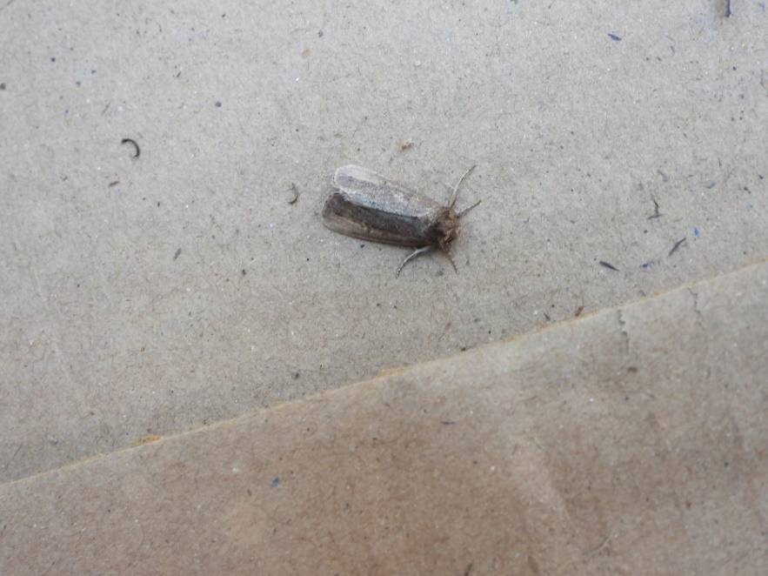

Picture 1E: *Pyralidae*-genera sps. Picture 1F: *Athetis* genera sps.

## 

Picture 1G: *Idaea* genera sps. Picture 1H: *Scopula emissaria*

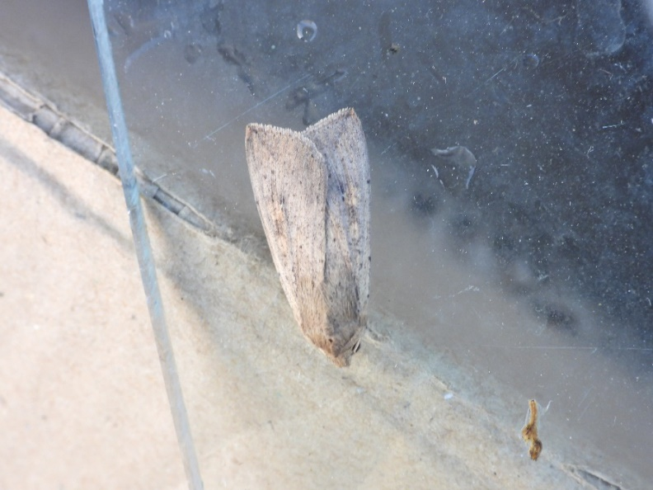 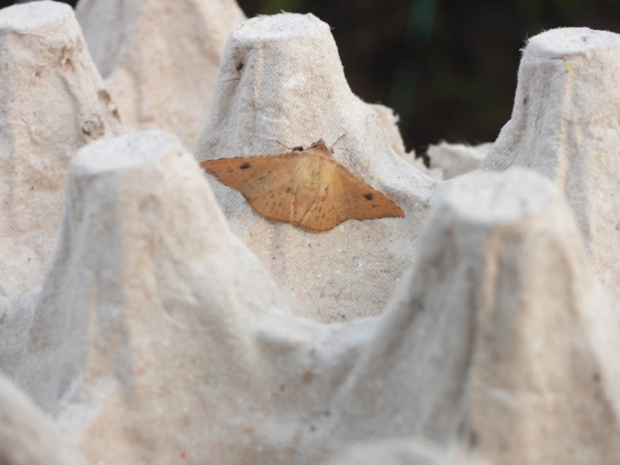

Picture 1I: *Mythimna separata* Picture 1J: *Ericeia inangulata*

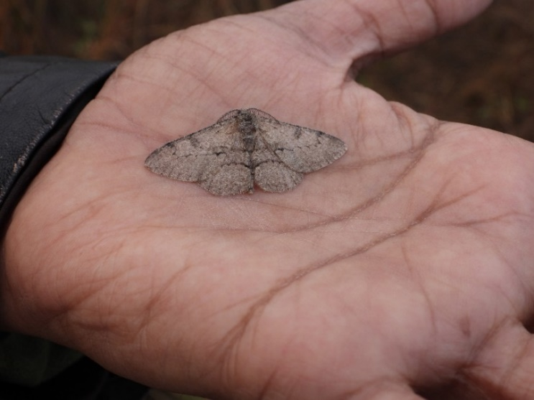 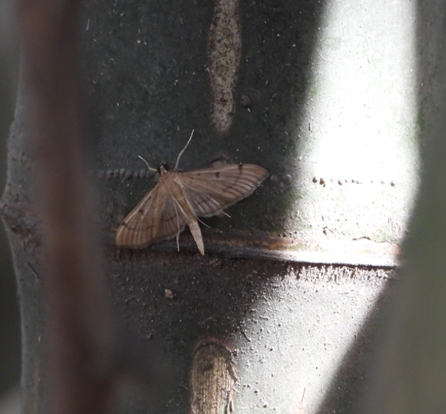

Picture 1K*: Chorodna strixaria* Picture 1L: *Bradina lederer*

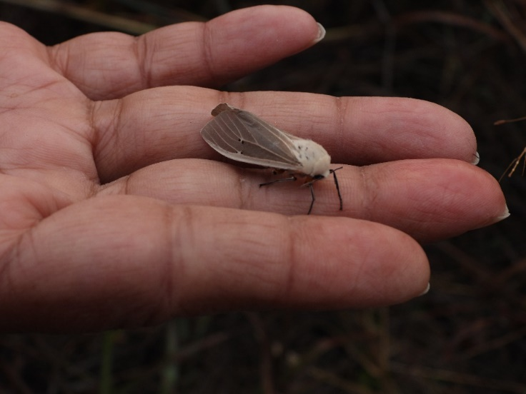 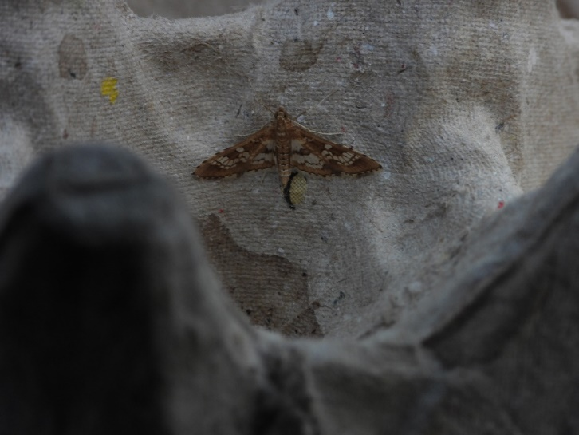

Picture 1M: *Creatonotos transiens* Picture 1N: *Sameodes cancellalis*

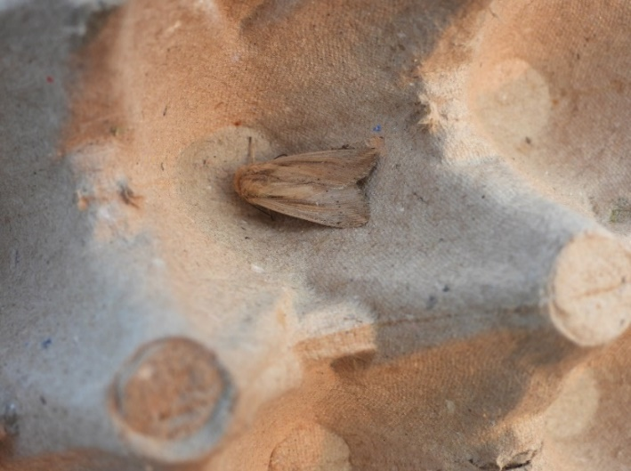 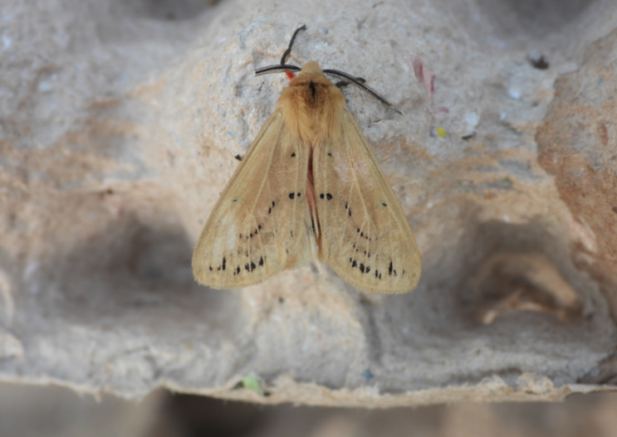

Picture 1O: *Leucania loreyi* Picture 1P: *Spilarctia obliqua*

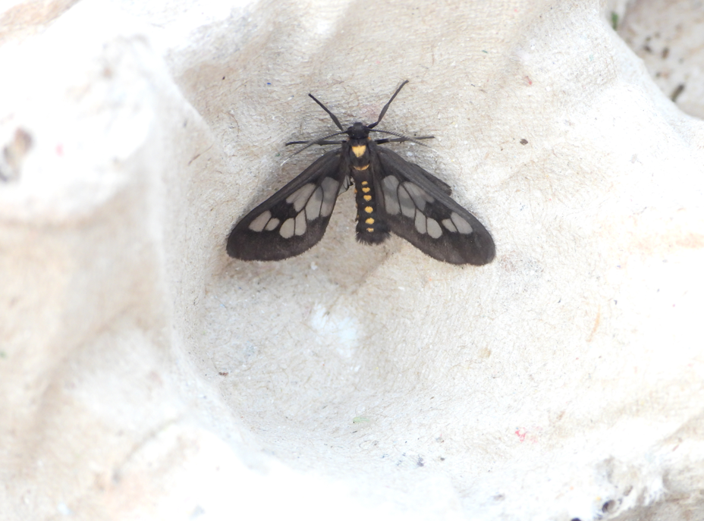 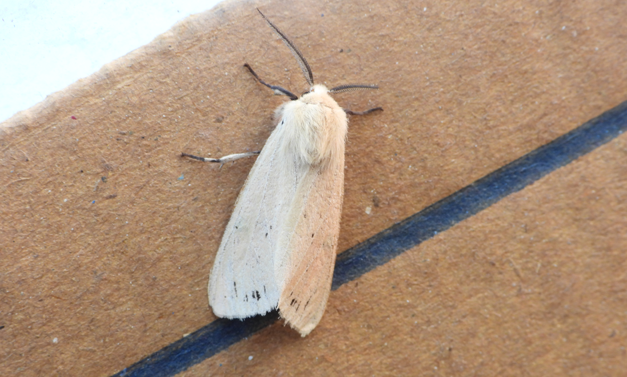

Picture 1Q: *Eressa confinis* Picture 1R: *Spilarctica-genera* sps*.*

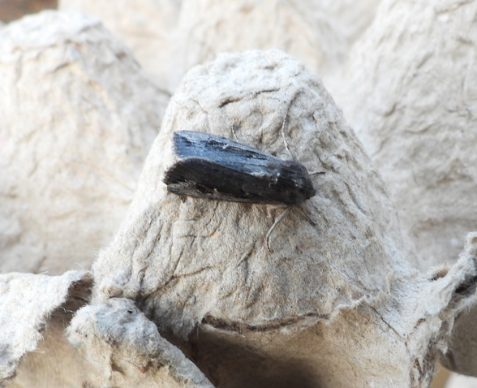 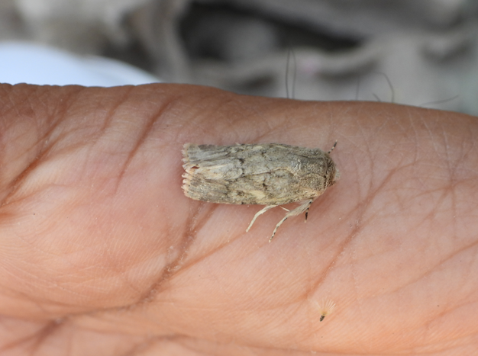

Picture 1S: *Brithys* *Crini* Picture 1T: *Caradrina* genera sps.

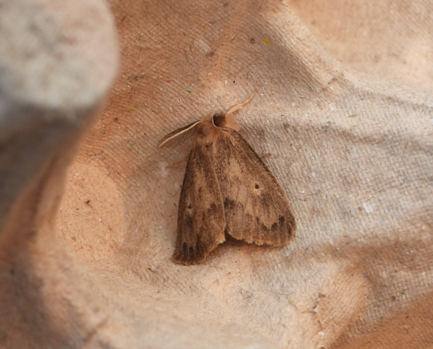 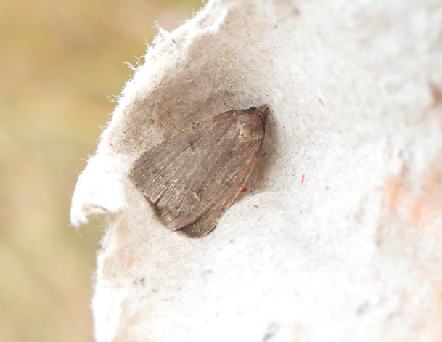

Picture 1U: *Lymantria ampla* Picture 1V: *Spodoptera*-genera sps.

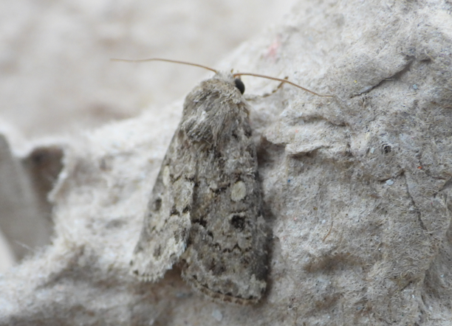 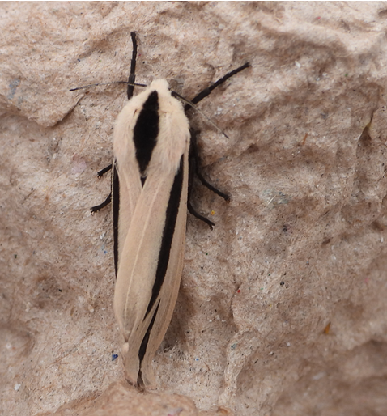

Picture 1X: *Spodoptera cilium* Picture 1Y: *Creatonotos gangis-interrupta* complex

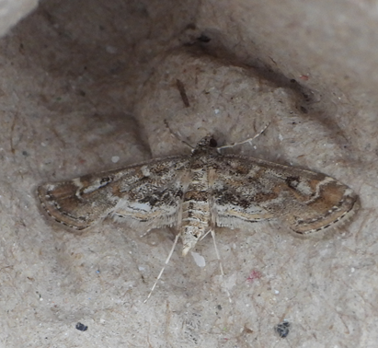 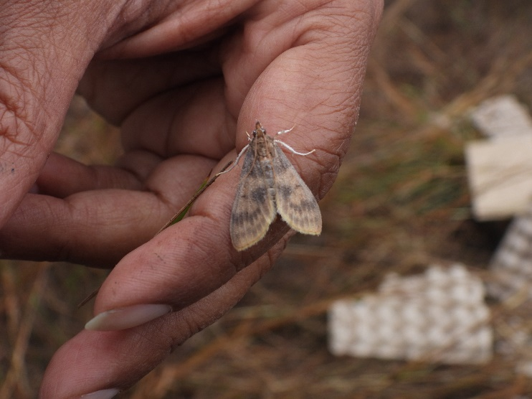

Picture 1Z: *Parapoynyx diminutalis*  Picture A1: *Uresiphita- genera* sps

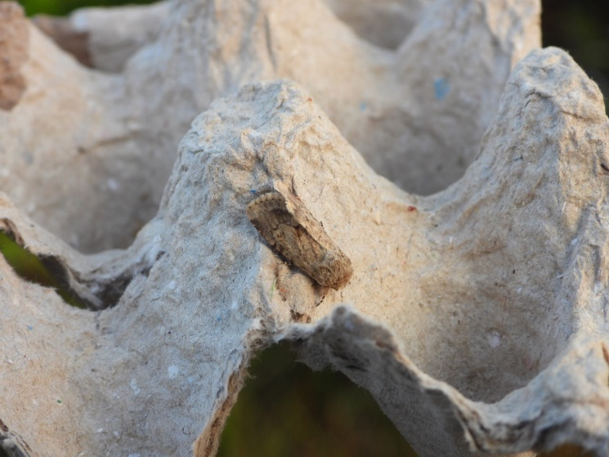 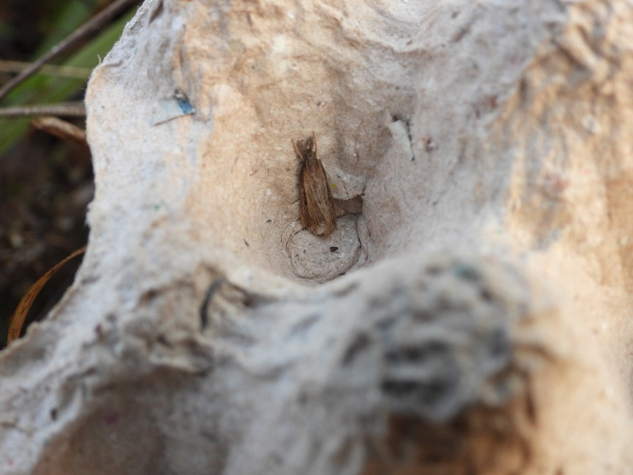

Picture B2: *Pandesma* -genera sps Picture C3: *Plodia interpunctella*

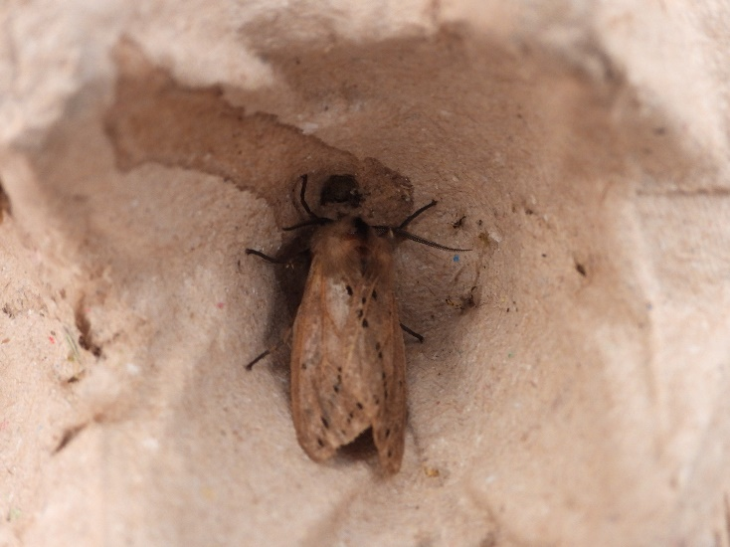 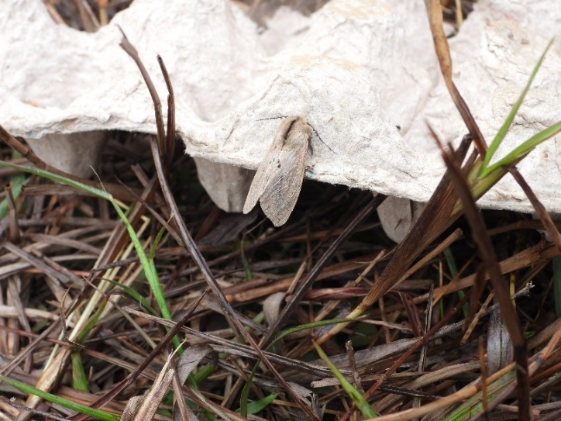

Picture D4: *Spilosoma*-genera sps. 1 Picture D5: *Spilosoma*-genera sps. 2

## Annex 2: Photographs of butterfly species shot frequently while resting on or interacting with their host plants.

## DSCN1316 DSCN1380

Picture 2A: Large Cabbage White (*Pieris brassicae*) Picture 2B: The Great Eggfly (*Hypolimnas bolina*)

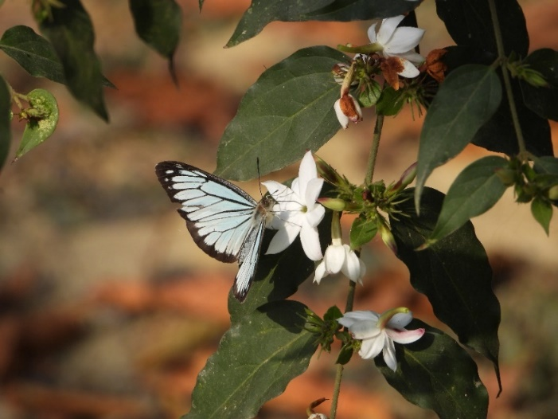 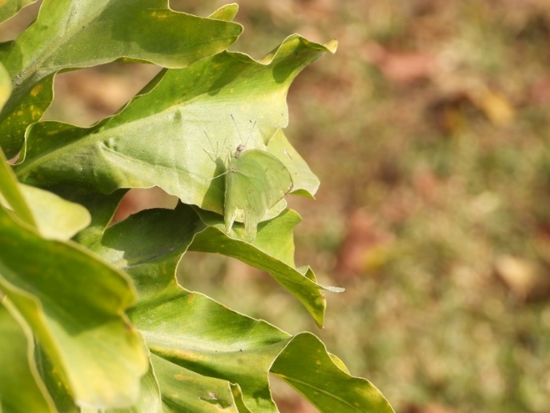

Picture 2C: Common Wanderer (*Pareronia valeria*) Picture 2D: Common Brimstone (*Gonepteryx rhamni*)

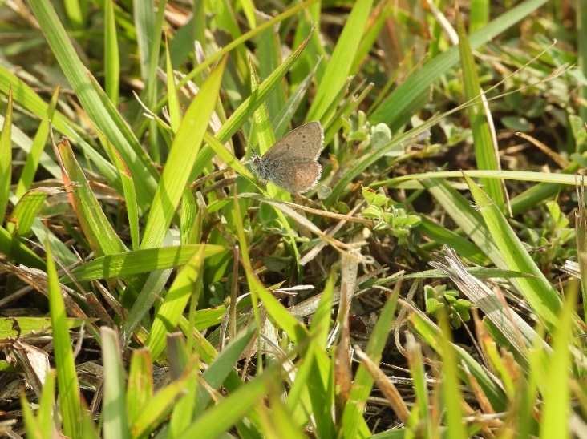 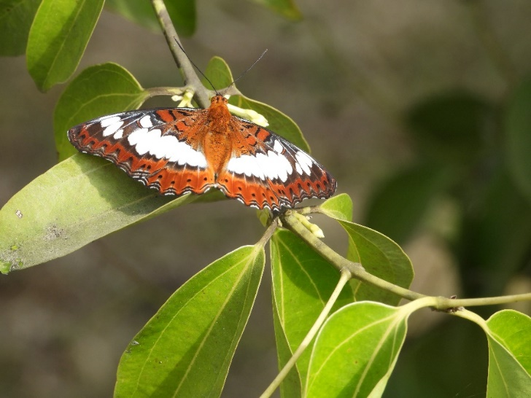

Picture 2E: Lesser Grass Blues (*Zizina otis*) Picture 2F: Commander (*Moduza procris*)

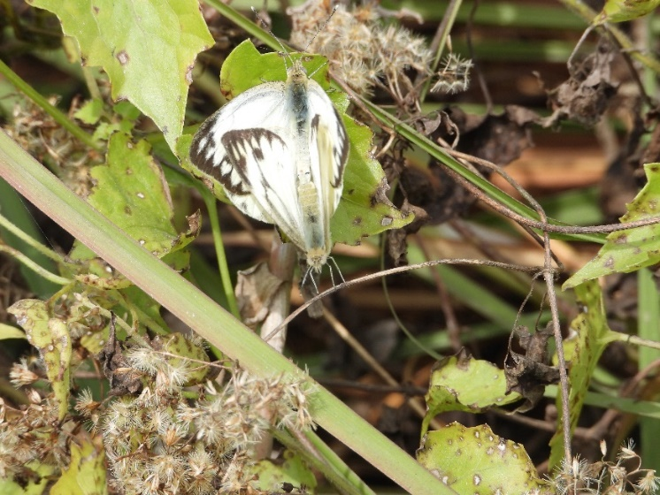 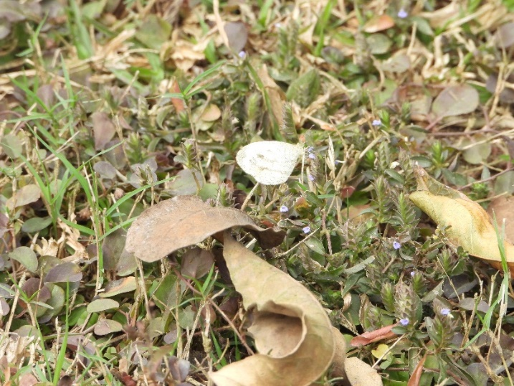

Picture 2G: Common Gull (*Cepora nerissa*) Picture 2H: Wandering Psyche (*Leptosia nina*)

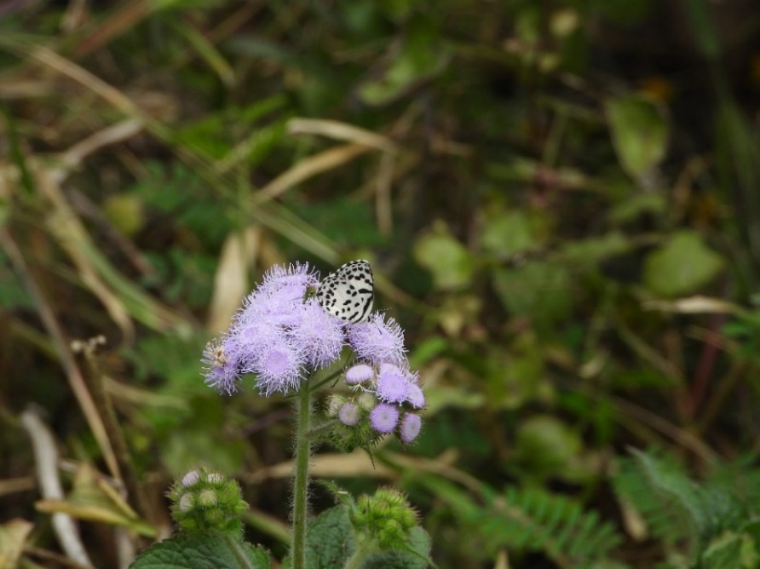 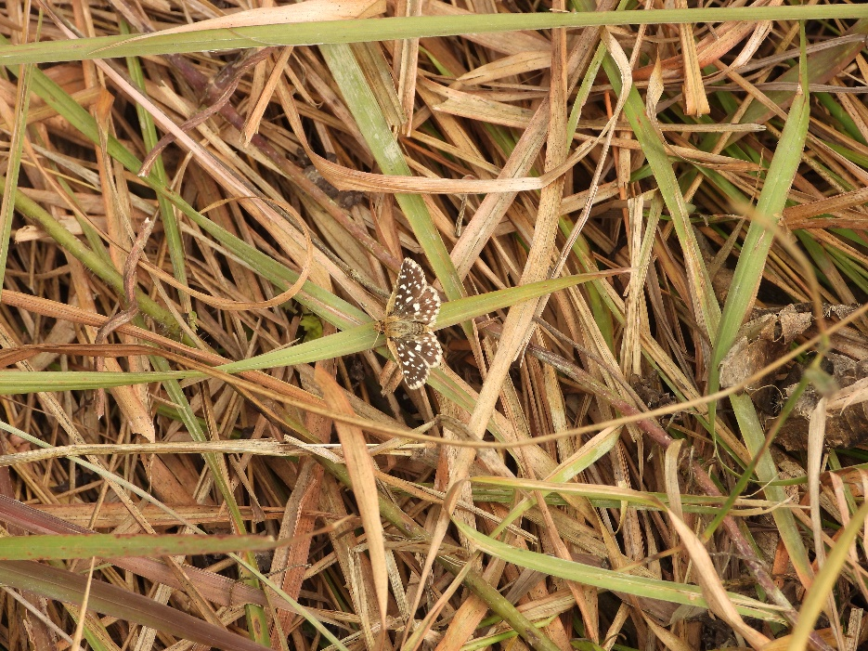

Picture 2I: Common Pierrot (*Castalius rosimon*) Picture 2J: Indian Grizzled Skipper (*Spialia galba*)

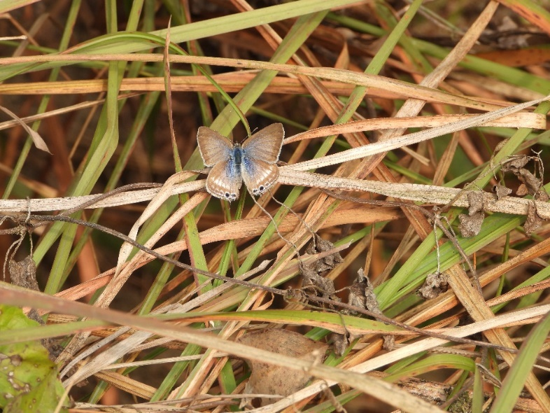 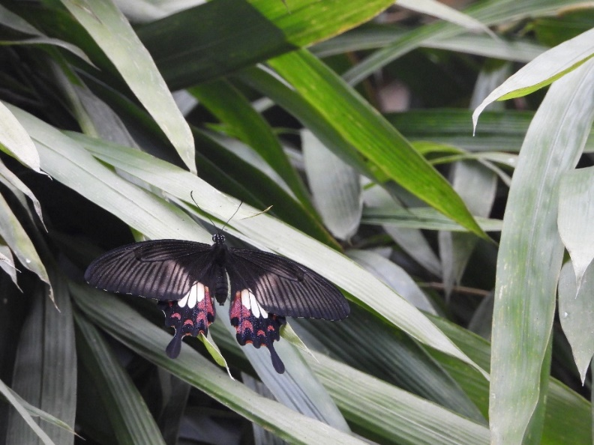

Picture 2K: Pea Blue (*Lampides boeticus*) Picture 2L: Common Mormon (*Papilio polytes*)

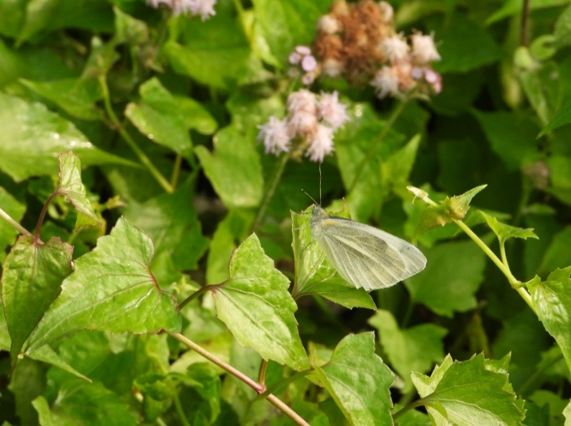 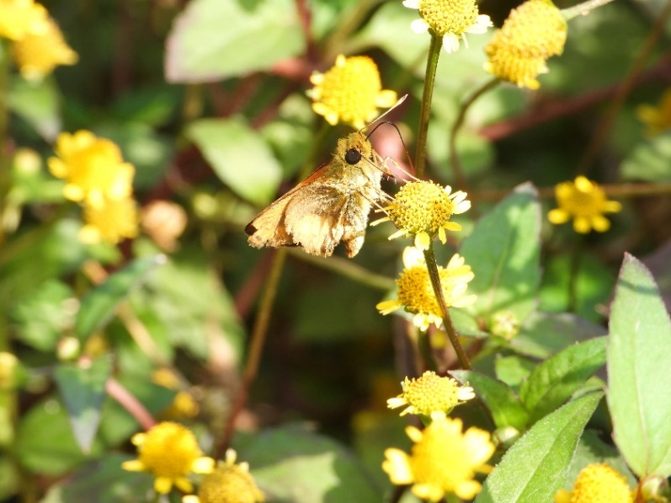

Picture 2M: Indian Cabbage White (*Pieris canidia*)Picture 2N: Common Dartlet (*Oriens gola*)

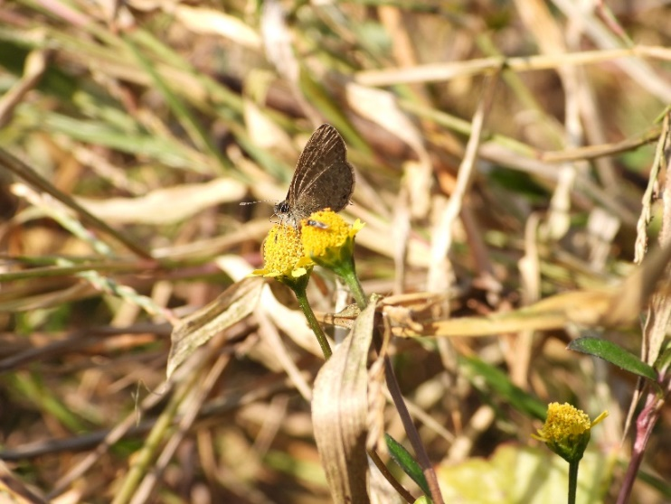 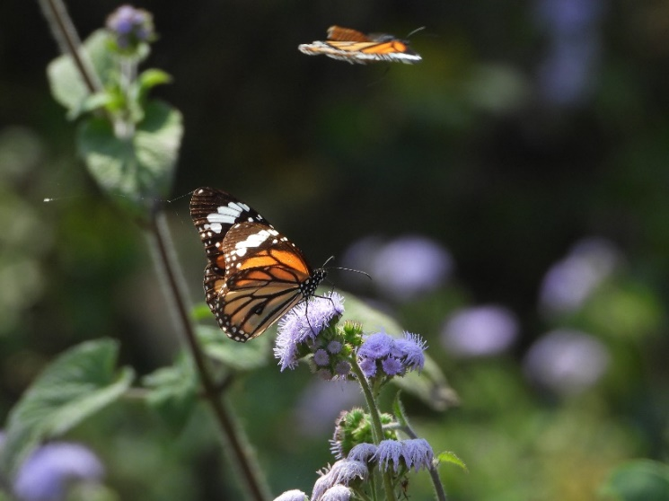

Picture 2O: Pale Grass Blues (*Pseudozizeeria maha*) Picture 2P: Common Tiger (*Danaus genutia*)

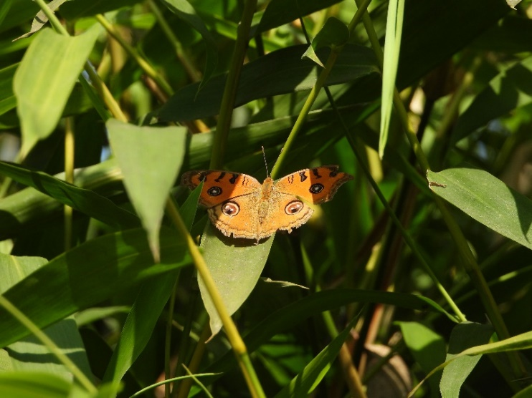 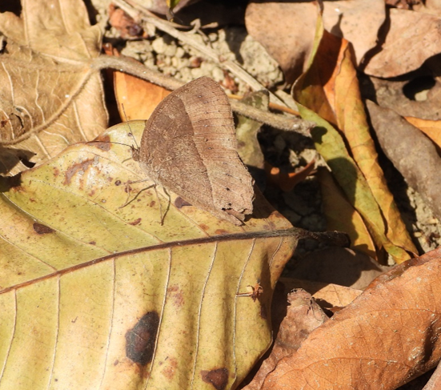

Picture 2Q: Peacock Pansy (*Junonia almanac*) Picture 2R: Great Evening Brown (*Melanitis zitenius*)

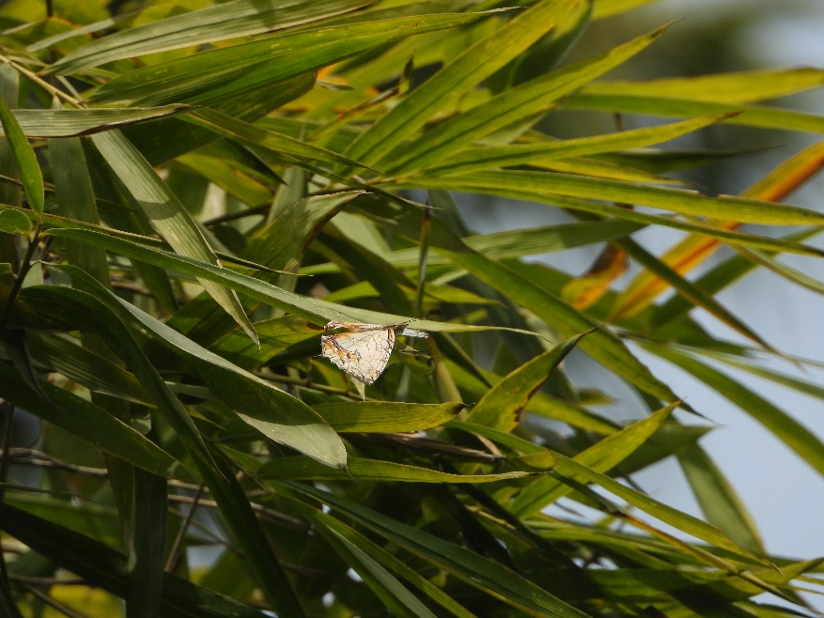 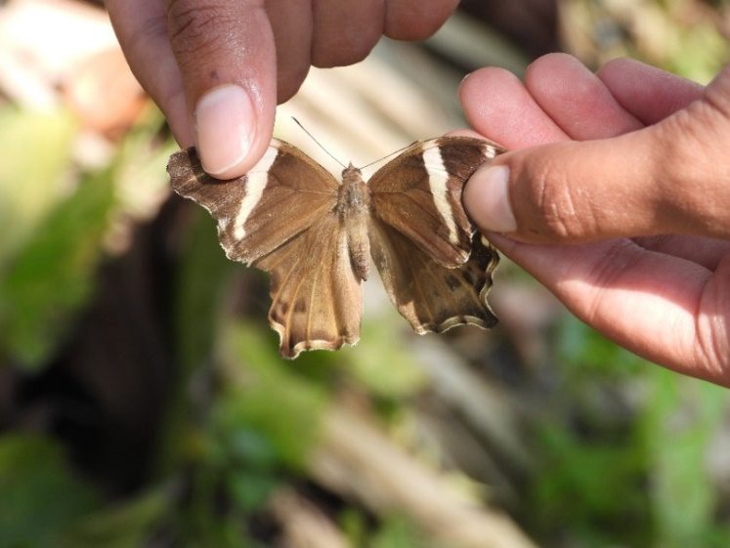

Picture 2S: Common Mapwing (*Cyrestis thyodamas*) Picture 2T: Bamboo Tree Brown (*Lethe europa*)

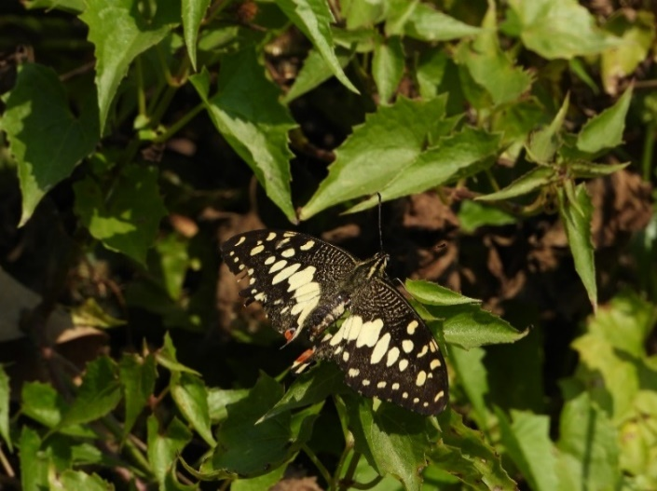 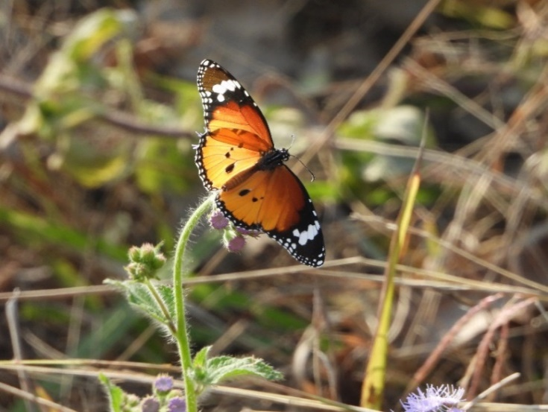

Picture 2U: Lime Swallowtail (*Papilio demoleus*) Picture 2V: Plain Tiger (*Neptis cartica*)

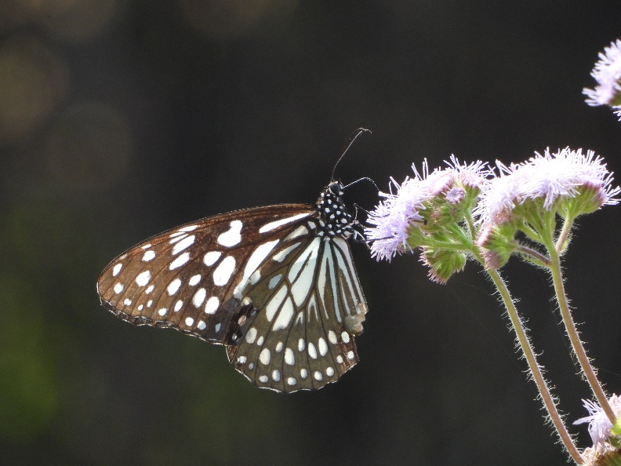 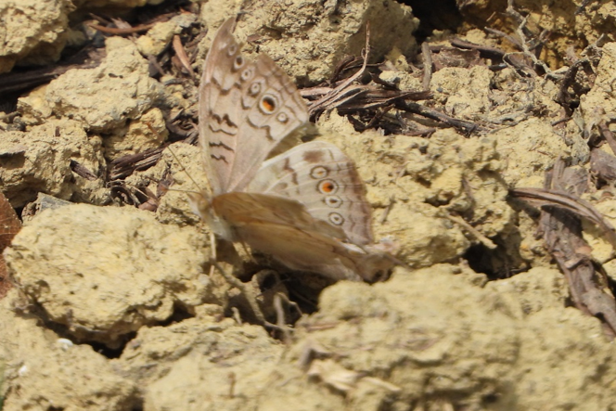

Picture 2W: Blue Glassy Tiger (*Ideopsis vulgaris*) Picture 2X: Grey Pansy (*Junonia atlites*)

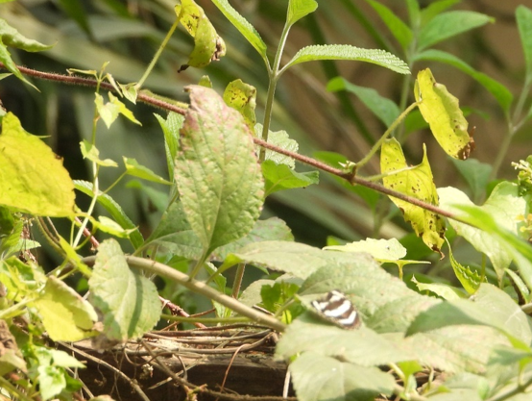 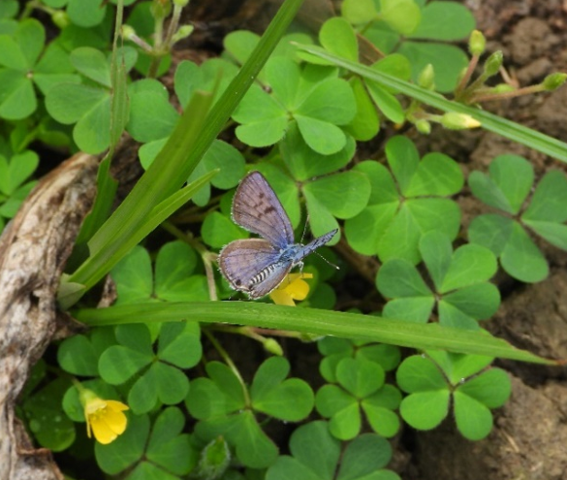

Picture 2Y: Plain Sailer (*Neptis cartica*) Picture 2Z: Black- spotted Pierrot (*Tarucus balcanicus nigra*)

## Annex 3: Photographs of Habitats that were explored for the butterfly diversity

## 

Picture 3A: Wetland habitat Picture 3B: Forested areas

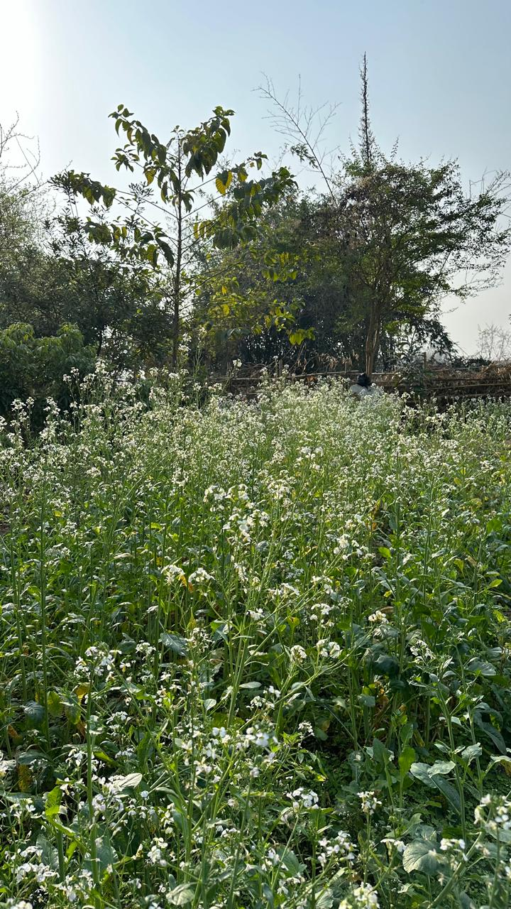 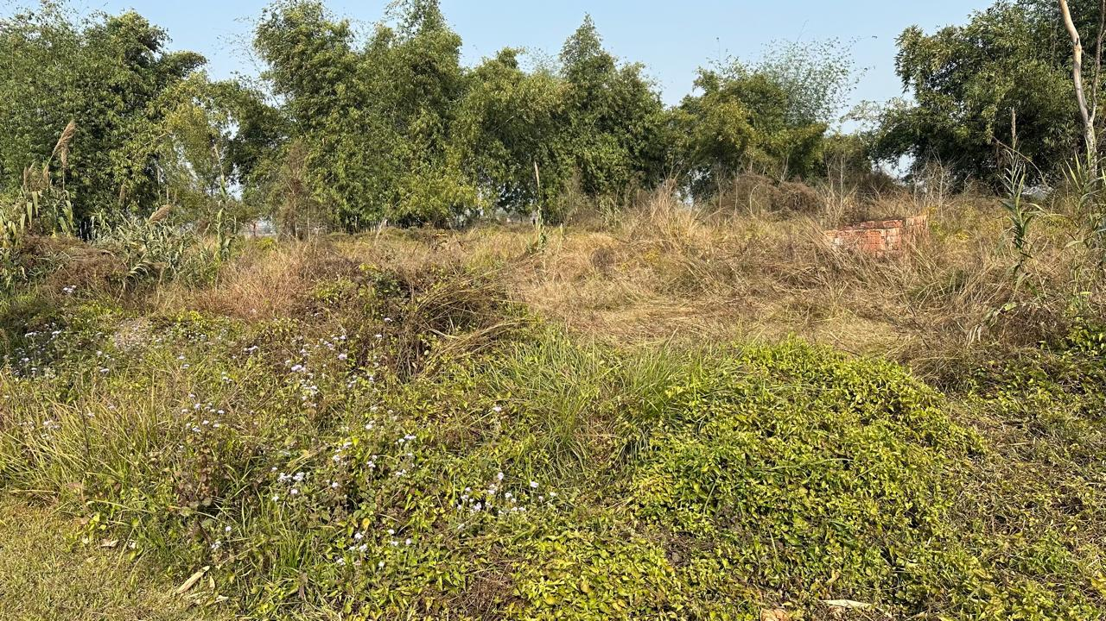

Picture 3C: Agriculture/ Farmland Picture 3D: Shrubland

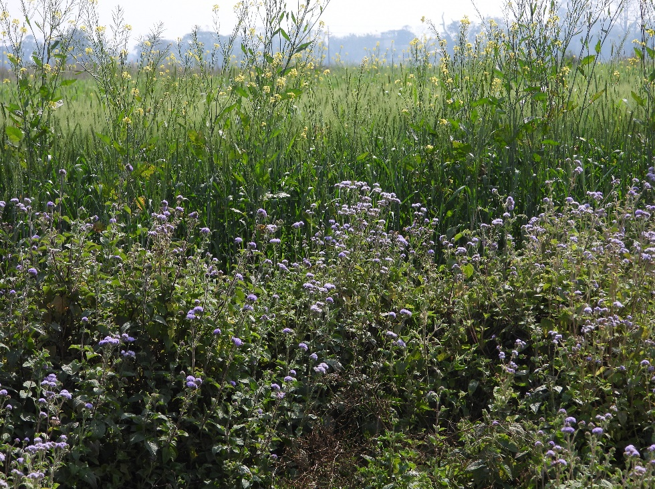 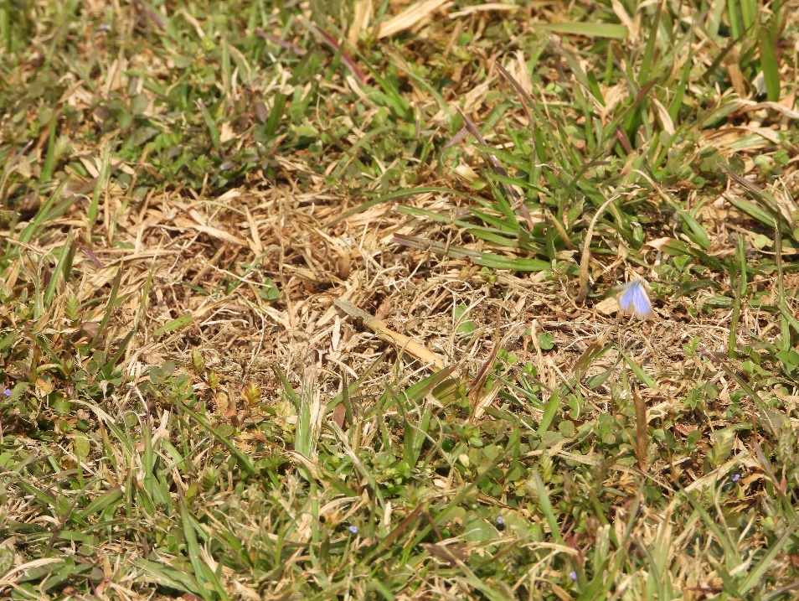

Picture 3U: Grassland Picture 3V: Grassland